KEY STROKES – BINOMIAL DISTRIBUTION

For the purposes of these examples assume n=15 and π = 0.4

- Calculate P(X = 9)

- DISTR 0↓binompdf(  Now enter the given data in the order n, π, X

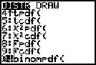
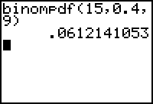
n π X

- Calculate P(X ≤ 3)

- DISTR A↓binomcdf(  Now enter the given data in the order n, π, X

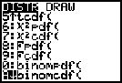
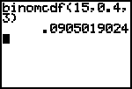
n π X

- Calculate P(X < 6)

- DISTR A↓binomcdf(  Now enter the given data in the order n, π, X
π
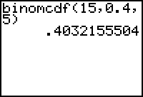
n X (Note that this X value
is 5 not 6 because we are
looking for X<6 and X is discrete. Think – this means that X
could be 0, 1, 2, 3, 4 or 5)
- Calculate P(X ≥ 9)

(Bear in mind that the TI 83 gives us the cumulative distribution frequency from 0 up to a given number – this is the number that you type in as “X”. When we are looking for the probability that X is GREATER THAN or GREATER THAN and equal to a certain number we are calculating 1 – P(X ≤ some number) )

P(X ≥ 9) means P(X=9,10,11,12,13,14,15) which is the same as 1 – P(X=0,1,2,3,4,5,6,7,8) OR

1 – P(X ≤ 8)

Key Strokes:

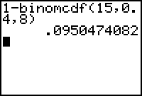
1 -  DISTR A↓binomcdf( 

Now enter the given data in the order n, π, X

- Calculate P(X > 9)

P(X > 9) means P(X=10,11,12,13,14,15) which is the same as 1– P(X=0,1,2,3,4,5,6,7,8,9)
OR

1 – P(X ≤9)

Key Strokes:

1 -  DISTR A↓binomcdf( 
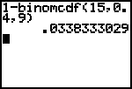
Now enter the given data in the order n, π, X

