THE NORMAL DISTRIBUTION

For the purposes of this worksheet take the mean as 50 and the standard deviation as 4. (μ = 50, σ = 4)

1. Calculate P(X < 45.8)

SKETCH KEY STROKES

 DISTR 2: 
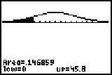
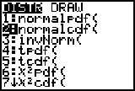

Select a ridiculous
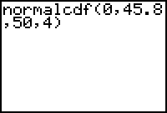
Lower bound Upper bound (the value in the question)

Type in the values in this order

(lower bound, upper bound, mean, SD)



Mean Standard deviation

- Calculate P(X > 52.3)
SKETCH KEY STROKES
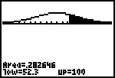
 DISTR 2: 

Type in the values as the question requires

(lower bound, upper bound, mean, SD) 

Value as given in Ridiculous upper bound (note that this is a run-on on the screen)
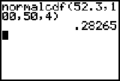

Answer

Mean Standard deviation

- Calculate P(45 < X < 52)
SKETCH KEY STROKES

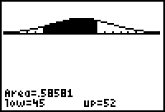
 DISTR 2: 

Type in the values as the question requires

(lower bound, upper bound, mean, SD) 

Lower bound Upper bound
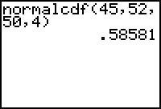
Mean Answer Standard deviation

NOTE: If you do not type in values for the mean and the standard deviation, the TI 83 assumes that the distribution is a STANDARD NORMAL DISTRIBUTION with μ = 0 and σ = 1.

INVERSE NORMAL DISTRIBUTION

In inverse normal problems, we are given the proportion and we are required to calculate a score.

In these examples we will use the same parameters as before viz μ = 50, σ = 4

- Calculate the value below which 23.5% of scores fall.
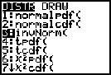
Key Strokes

 DISTR 3: 

Type in the values as the question requires

(area LEFT of the required score, mean, SD) 

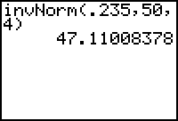
AREA LEFT OF THE REQUIRED
SCORE expressed as a decimal fraction Mean Standard
deviation

ANSWER: 47.11 (4sf) is the score below which 23.5% of scores lie.

- Calculate the score above which 0.31 of the population lie.

Key Strokes

 DISTR 3: 

Type in the values as the question requires

(area LEFT of the required score, mean, SD) 

1 – 0.31 = 0.69

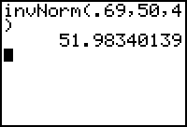
Mean

Standard deviation

