Numerical Methods Using a Graphics Calculator

Bisection Method using table and graph
To solve
Enter the function in □ Press , choose 6: Standard Graph is drawn
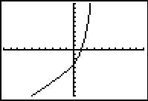
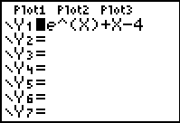
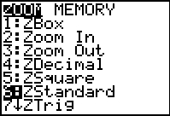 Press  or 

Experiment with the  settings to show the x-intercept more clearly.

Obtain a table of values by first setting up the table. Press   to access TBLSET.

Choose a starting value for the Press   to view the table.
table, say –1, and a step of 1. You can scroll up and down the table to
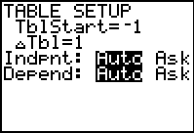
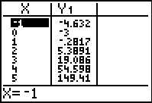
see more values.

Complete this table and plot the graph to show the x-intercept on the axes below.

x
f(x)

Bisection Method continued
From the table, the solution to f(x) = 0 is in the interval [1, 2]
because f(1) = ________ which is negative/positive
and f(2) = ________ which is negative/positive.
Return to TABLESET: press  . Press   to view the new table.
Start at the left bound of the interval above,
halve the step size. Hint: divide the step by 2
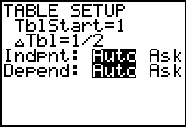
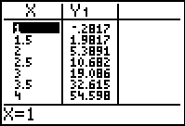
to ensure no errors in the step size!

Which interval now encloses the solution? The solution is in the interval [ , ]
because f( ) = ________ which is negative/positive
and f( ) = ________ which is negative/positive.

Repeat these steps for three more iterations.

The solution is in the interval [ , ]
because f( ) = ________ which is negative/positive
and f( ) = ________ which is negative/positive.

The solution is in the interval [ , ]
because f( ) = ________ which is negative/positive
and f( ) = ________ which is negative/positive.

The solution is in the interval [ , ]
because f( ) = ________ which is negative/positive
and f( ) = ________ which is negative/positive.

Use your final interval to calculate an approximate solution to the equation
An approximate solution is because __________________________________
___________________________________________________________________________
___________________________________________________________________________

Numerical Methods Using a Graphics Calculator

Newton-Raphson Method using the ANS memory
To find the positive solution to solve
Enter the function in □ Press choose 6: Standard Graph is drawn
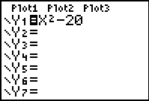
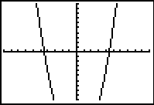
Press  or 

Experiment with the  settings to show the positive x-intercept more clearly.
Obtain a table of values by first setting up the table. Press   to access TBLSET.
Choose a starting value for the Press   to view the table.
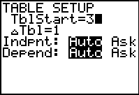
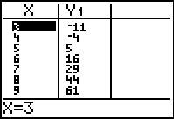
table, say 3, and a step of 1. You can scroll up and down the table to
see more values.

Complete this table and plot the graph on the axes given.
x
f(x)

Newton-Raphson Method continued
Differentiate: to obtain
Set up the NR formula and do not simplify:
Press   to quit TABLE and go to the home screen.
Choose a starting point, say
Press•  to store the initial value, , in the ANS memory.
Enter the NR formula in its full form using ANS instead of , by pressing  each time.

ANS – (ANS² –20)/(2*ANS)

Press  to obtain the value for ________________
Press  to obtain the value for ________________
Press  to obtain the value for ________________

An approximate solution is

