KEY STROKES – POISSON DISTRIBUTION

For the purposes of these examples assume λ = 7

- Calculate P(X = 9)

- DISTR B:poissonpdf(  Now enter the given data in the order λ, X

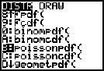
λ X
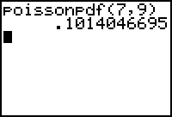

- Calculate P(X ≤ 3)

- DISTR C:poissoncdf(  Now enter the given data in the order λ, X

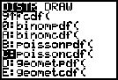
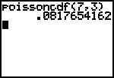
λ X

- Calculate P(X < 6)

- DISTR C:poissoncdf(  Now enter the given data in the order λ, X

(Note that this X value is 5 not 6 because we are
looking for X<6 and X is discrete. Think – this means that
X could be 0, 1, 2, 3, 4 or 5)
X

λ
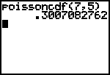

- Calculate P(X ≥ 9)

(Bear in mind that the TI 83 gives us the cumulative distribution frequency from 0 up to a given number – this is the number that you type in as “X”. When we are looking for the probability that X is GREATER THAN or GREATER THAN and equal to a certain number we are calculating 1 – P(X ≤ some number) )

P(X ≥ 9) means P(X=9,10,11,12,13,14,…….) which is the same as 1 – P(X=0,1,2,3,4,5,6,7,8) OR

1 – P(X ≤ 8)

Key Strokes:

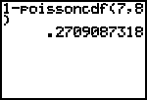
-  DISTR C:poissoncdf( 

Now enter the given data in the order λ, X

- Calculate P(X > 9)

P(X > 9) means P(X=10,11,12, ……) which is the same as 1– P(X=0,1,2,3,4,5,6,7,8,9)
OR

1 – P(X ≤9)

Key Strokes:

1 -  DISTR C:poissoncdf( 
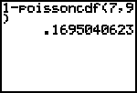
Now enter the given data in the order λ, X

