Excel

Contents:
Do you have the Data Analysis ToolPak?
Drawing a Scatter Plot
Sample Correlation Coefficient
Simple Linear Regression
Adding a Trend Line and its Equation to a Scatter Plot

Do you have the Data Analysis ToolPak?

- Click Tools on the menu bar.
If Data Analysis is on list then you have the Data Analysis ToolPak add-in and there is nothing else to do.
If you don’t see Data Analysis then complete the following steps.
- Click Add-Ins from the Tools list.
- Click in the Analysis ToolPak checkbox (Figure 1).
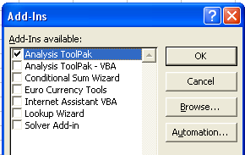
Figure 1
- Click OK
- Repeat Step 1 to check that the Data Analysis ToolPak has been added to the Tools list.

Drawing a Scatter Plot
Example:
Using the Car data, construct a scatter plot of Eng against Weight

- Open the Excel file containing the car data as seen in Figure 2.
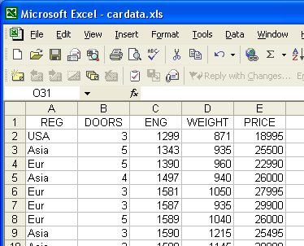
Figure 2

- Click Insert on the menu bar, then click Chart.

- Click XY (Scatter). Click Next (Figure 3).
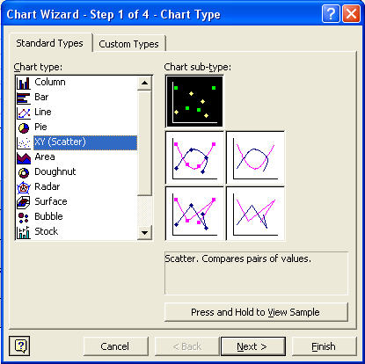
Figure 3

- Click in Data Range box (Figure 4).
Click and hold on Cell C1 in the worksheet and drag cursor to Cell D61.

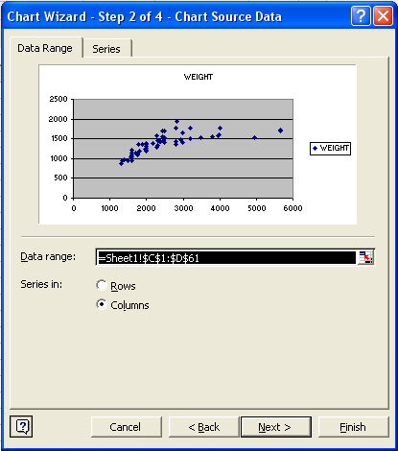
Figure 4

- Check the settings for each of the options in Step 3 of the Wizard as in Figure 5.

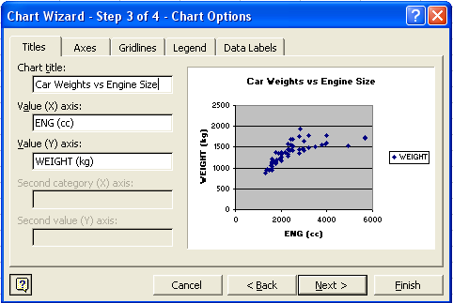
Figure 5a: Titles

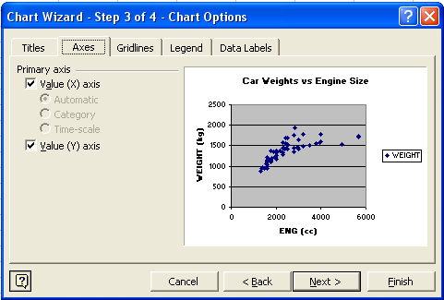
Figure 5b: Axes
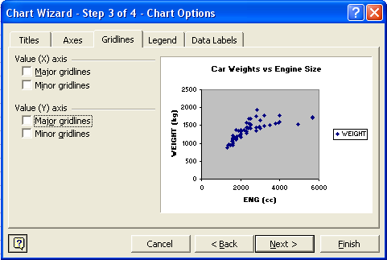
Figure 5c: Gridlines
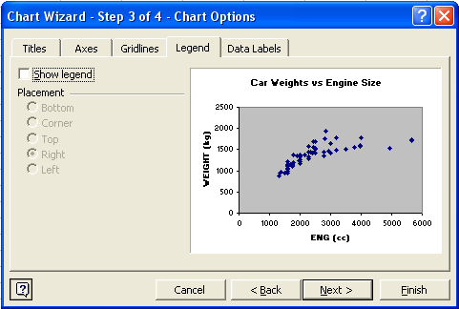
Figure 5d: Legend

- Click Next and then Finish.

Sample Correlation Coefficient

Example:
Using the Car data, find the sample correlation coefficient, r, between Eng and Weight for those cars with an engine size of less than 2500cc.

- Open the Excel file containing the Car data as seen in Figure 6.

Figure 6

- Click Tools on the menu bar, then click Data Analysis in the list.

- The Data Analysis dialog box appears (Figure 7). Select Correlation, then click OK.

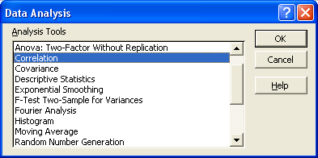
Figure 7

- Fill in the Correlation dialog box as shown below (Figure 8).

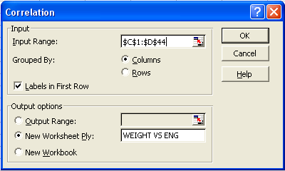
Figure 8

- Input Range is $C$1:$D$44 (or C1:D44)
- Labels in First Row checkbox ticked (range include the variable names/labels in the first row)
- New Worksheet checkbox ticked and WEIGHT VS ENG is entered as the name for this new worksheet which will contain the correlation coefficient output.

- Click OK to produce the output below (Figure 9).

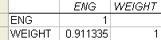

Figure 9
Simple Linear Regression

Example:
Using the Car data, regress Weight on Eng for those cars with an engine size of less than 2500cc.

- Open the Excel file containing the car data as seen in Figure 10.

Figure 10

- Click Tools on the menu bar, then click Data Analysis in the list.

- The Data Analysis dialog box appears (Figure 11). Select Regression, then click OK.

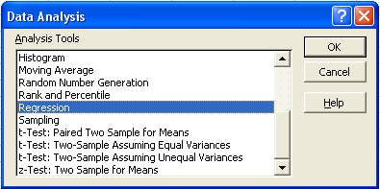
Figure 11

- Fill in the Regression dialog box as shown below (Figure 12).

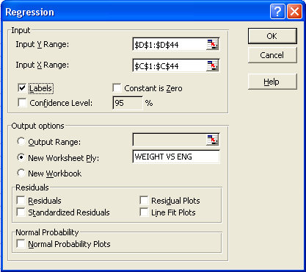
Figure 12
  - Input Y range is $D$1:$D$44 (or D1:D44)
  - Input X range is $C$1:$C$44 (or C1:C44)
  - Labels checkbox ticked (ranges include the variable name/label in the first cell)
  - New Worksheet checkbox ticked and WEIGHT VS ENG is entered as the name for this new worksheet which will contain the regression output

- Click OK to produce the output below (Figure 13).

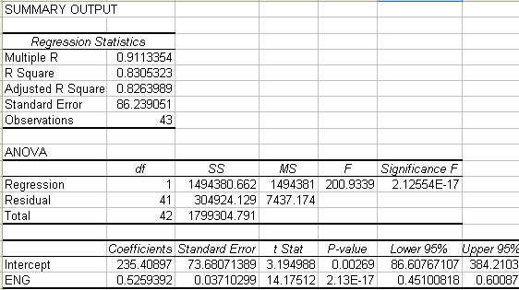
R ²
r
s
n
Figure 13

Adding a Trend Line and its Equation to a Scatter Plot

Example:
Add a least squares regression line a scatter plot of WEIGHT against ENG for cars
of less than 2500cc.

- Click on the scatter plot so that the plot is active.

- Click Chart in the menu bar and then Add Trendline. (Figure 14)
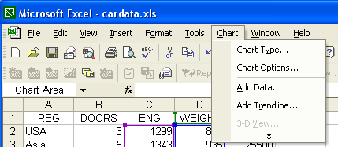
Figure 14

- Click Options and tick the boxes shown in Figure 15.
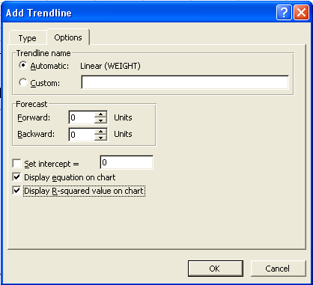
Figure 15

- Click OK, the scatter plot with the trend line and its equation should appear as in
Figure 16.
Figure 16

Note: The plot has been resized, the x-axis has been scaled to start at
1100cc and some line borders have been removed.

