University of Auckland
Department of Statistics
Tamaki Campus
Thursday November 20

Time Series Workshop
Lindsay Smith, Bernice Popham, Lesley McHardie

Features of Time Series (Belle’s Dairy Farm)
Calculations using Excel (Hotel Nights)
- Graphing the raw data and establishing the trend
- Forecast for Nov 03 (merit)
- Seasonally adjusted values (excellence)

Contents of handbook
Part 1 :Towards Achievement
Graphing the raw data
Smoothing techniques
Establishing a numerical value for the trend
Establishing the equation of the trend

Part 2: Towards Achievement with Merit
Calculating trend values
Calculating seasonal effects
Making the forecast

Part 3: Towards Excellence
Seasonally adjusting data
Interpreting seasonally adjusted data
Fitting a non-linear trendline

Appendix: Statistics and Modelling Achievement Standard 3.1
Statistics and Modelling Name: ____________________________

Analysing Time Series Data with Excel

Part 1: Towards Achievement
Describing the trend for Time Series Data

a) Graphing the raw data

Log on as directed by your teacher
Open Excel and find the file called sams icecream.
This data is a time series of the value of icecream sales by Sam over a period of three years at quarterly intervals in thousands of dollars.
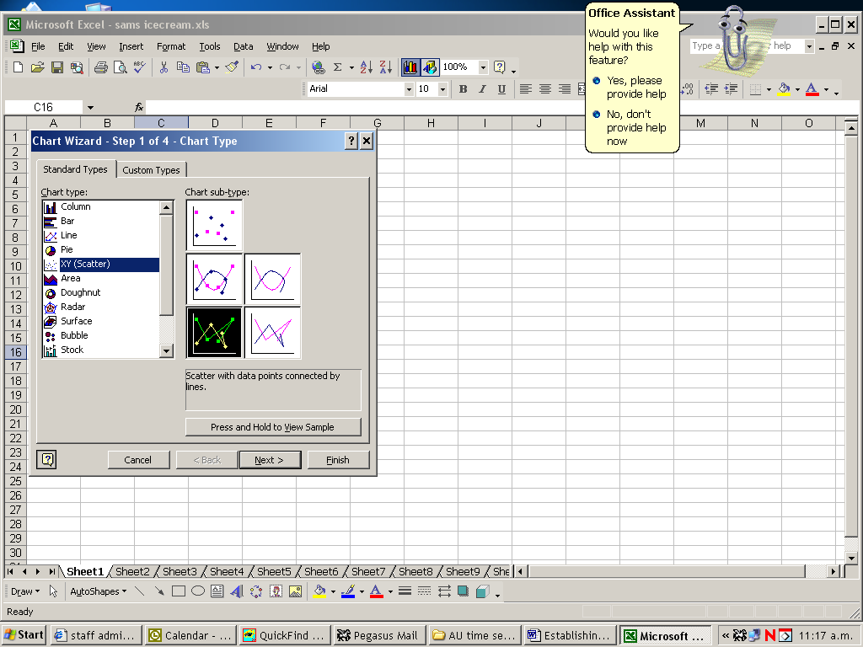

To draw a graph of the raw data
Using the mouse select cells B2 to B14 and C2 to C14

On the tool bar click on the Chart icon (it looks like a bar graph)
Chart Step 1 of 4 - Chart Type
Standard Types
Chart type: XY (scatter)
Chart sub-type: scatter with data points connected by lines
Next

Steps 2 to 4 – Work through the rest of the steps in the chart wizard

The graph can be modified, for example to change the y axis scale click on the y axis, click on Format on the tool bar, and select y axis.

Use the graph to note important features of the time series, such as the trend, seasonal variation, spikes and ramps.

b) Smoothing techniques: calculating moving means

When you have completed this computer exercise you will be able to use Excel to calculate
- odd and even moving means

To calculate odd point moving means
Log on as directed by your teacher and find the file called absences. This data is a time series of the number of absences by year 12 students over a four week period. Produce a graph of the raw data in the usual way. Note that the data has seasonality of order 5 so we will calculate 5 point moving means.

In cell C1 type moving mean (mm)
Select cell C4 and select Insert on the tool bar
Function
Average OK
Select B2 to B6 OK
Copy this formula into cells C5 to C19 by click and drag or
Select cells C4 to C19
On Toolbar click Edit or click on C
Fill drag right hand bottom corner when + sign appears
Down down to C19
You now have the moving means in column C.

To draw the graph of the raw data and the moving means
Firstly insert a column for the time period numbers
Click on the grey area at the top of column B
Click on Insert on the toolbar
Select Columns
Use this column to number the time periods from 1 to 20

Select B2 to B21 and C2 to C21 and D2 to D21

On the Toolbar click on the graph icon.
Follow the steps of the chart wizard as before.
Note that the trend is apparent from the graph of the moving mean.

c) Establishing a numerical value for the trend from the moving means

This can be calculated using the first and last values of the moving mean:
In F1 type trend value
In F3 enter =(D19-D4)/(B19-B4)

The number of absences is decreasing by 0.08 per day.

For further practice access the file “sleep”. This time series data records the number of hours of sleep had by a seventh former over a four week period. Note that in this case you will need to leave three empty cells at the top of the moving average column and three empty cells at the bottom. You may round the values in the cells
Select Format on the toolbar
Cells
Number
Select the required number of decimal places

d) Using a spreadsheet to calculate a moving mean of even order

When we calculate the mean of an even number of terms the mean should be plotted between the middle two periods. This is inconvenient for plotting and calculation of seasonal effects so to bring the mean opposite a time period we must calculate the mean of two consecutive means. The end result is that for a moving mean of order 4 there will be two blank time periods at the beginning and end of the moving averages.
For practice, access the file shellfish. The data in this time series gives the three monthly total of exports of crustaceans in $m from NZ from September 91 to December 95.

We will calculate a moving mean of order 4.
In cell D1 type moving mean (mm)
In D3 type the formula for finding the mean of the first four data values
=sum(B2:B5)/4 (or use the AVERAGE function)
Copy this formula into cells D4 to D17

Select cell E1 and type centred moving mean (cmm)
In D4 type the formula for finding the average of the first two moving means.
=sum(D3:D4)/2 or use the AVERAGE function
Copy this formula into E5 to E17

Note that there are two blank cells at the start of the centred moving means and two at the end as required.
You can now graph the raw data and the moving means on the same graph and comment on the Time Series components present in the data.

For further practice access the file VisNZ which gives monthly data for the number of visitors to NZ from January 77 to September 96.
Smooth the time series by calculating and plotting suitable moving means. Comment on the features of this Time Series data.
Calculate the trend value for this data.

e) Establishing the equation of the trend
In Excel it is possible to fit a linear trend line of best fit and establish its equation.

Return to the absences file and graph showing the raw data and moving mean

To draw the trend line on the graph

Right click on the graph of the moving mean. Highlights will appear.
Select Chart on the Toolbar
Select Add Trendline
Under Type select Linear ( note that different types are available)
Make sure Series 2 is highlighted
Click on Options
select display equation on chart and
select display R-squared value on chart
The trend line should now be visible on the graph, and its equation presented.

The equation should appear as
y = -0.0618x + 16.42
R² = 0.1034

R² is known as the correlation coefficient. It is a measure of how well the data fits the trend line: the closer to one the better the fit. You can experiment with different trend lines from the menu and compare values for R². The trend line which gives the highest value for R² fits the data best. Achievement in Standard 3.1 requires only the fitting of a linear trend line. For excellence you may fit another model.

You can choose the location of the graph you are working on either from step 4 of the Chart Wizard or by selecting the graph, right click and select Location either As New Sheet or As object in.

Practise this technique with Shellfish.
y = 0.3688x + 27.804
R² = 0.7154
Your results should be

Part 2: Towards Achievement with Merit

Making a forecast
When you have completed this computer exercise you will be able to use Excel to calculate
- Trend values
- seasonal effects
- a forecast

To make a forecast for a particular time period we must combine the trend value and the effect of a particular season.
We will use the formula
Forecast = T(rend) + S(easonal effect)

a) calculating the trend values

Log on as directed by your teacher
Open Excel and find the file called sams icecream
We will use the data to make a forecast for the trend value for Summer 04.

Using columns D and E calculate the set of moving means and centred moving means for the data, and from the graph establish the trend line equation. You should obtain

sams icecream sales
y = 16.783x + 713.88
R
2
= 0.9296
0
200
400
600
800
1000
1200
1400
0
5
10
15
time period
$000
Raw data
Centred moving mean
Linear trend line)

We can interpret this as meaning that Sam’s icecream sales are increasing at about 17 per season.
We will now use the formula for the trendline to calculate trend values.

In A15 to A17 type in the next time periods.
In B15 to B17 extend the time period values 13, 14, 15.
In cell F2 type “trend” Select cell F3 and enter the formula for the equation using the time period value as x.
=16.783*B3 + 713.88

Copy this formula into cells F4 to F17 in the usual way.
Select cells D3 to D17
On Toolbar click Edit or click on cell F3
Fill drag right hand bottom corner when + sign appears
Down down to F17

You now have the trend values for the raw data and the next three time periods in column F.

b) Calculating seasonal effects

We will first calculate individual seasonal effects for each season that has a centred moving mean.

In G2 type Individual Seasonal Effect (ISE)
To wrap text, select the cell, click on format on tool bar.
Select Cells
Select alignment
Under text control tick wrap text OK

In G5 we will calculate the individual seasonal effect for autumn 01, that is the difference between the raw data and the centred moving mean.
= C5 – E5

Copy this formula down to G12.

In cells A20 to A24 type autumn, winter, spring,summer.
Select cells G5 to G8. These values are the first four individual seasonal effects. We will paste them at the bottom of the spreadsheet in B20.
On Toolbar click on Edit
Copy
Click on cell B20
On Toolbar click on Edit
Paste Special
Click on values
OK
The first four individual seasonal effects will appear in column B
Select the next four individual seasonal effects and paste into column C.
To calculate the seasonal effect, take the average of the two individual effects for each season.
In D20 Insert
function
Average B20 to C20
Copy this formula down to D23

We will now paste these values opposite the corresponding season in column H, including those seasons we wish to make a forecast for.
In H2 type seasonal effects (SE)
Select D20 to D23
From Edit on tool bar select Copy
Click on cell H5
From Edit on tool bar select Paste Special
Click on Paste Values

Click on Cell H9
From Edit on tool bar select Repeat Paste Special

Keep pasting until you have a seasonal effect opposite each raw data value, including those at the start of the time series. Be careful that the seasonal effect corresponds with the time period!

c) Making the forecast

To make a forecast for a particular time period we must combine the trend value and the effect of a particular season.
We will use the formula
Forecast = T(rend) + SE

In I2 type forecast
In I17 enter the formula
=F17 + H17

=F17 + H17

This will result in a forecast for Autumn 04 as 928.2 thousand dollars! Bold it!

To check the reliability of the model, generate forecast values for all time periods and compare them with the raw data values.

Save your spread sheet for part 3.

Practise with another set of data.

Part 3: Towards Excellence

Seasonally adjusting data

When you have completed this computer exercise you will be able to use Excel to
- calculate seasonally adjusted values
- interpret seasonally adjusted values

To calculate Seasonally adjusted values
A seasonally adjusted value is a raw data value with the seasonal effect removed.
It can then be compared with the (centred) moving mean. If it is greater than the moving mean the raw data value is greater than can be expected for that particular season.

SAV = RAW - SE

Using your Sam’s icecream sales worksheet,
In J2 type SAV (seasonally adjusted value)
= C3 - H3
In J3 enter the formula

Copy this formula into cells J4 to J14

You can now draw a graph of the raw data, moving means and seasonally adjusted values.
(To highlight non-adjacent columns hold down the control key before clicking on the required cells).
On days where the seasonally adjusted value is higher than the moving mean the sales are higher than expected. You can also get similar information from the spreadsheet by calculating seasonally adjusted value minus the moving mean for each day (in column G). Absences are higher than expected on days where these values are positive.

For which time periods were the sales higher than expected?

For further practice with an even moving mean access the shellfish data and the VisNZ data. For each set of data calculate
- moving means,
- individual seasonal effects,
- seasonal effects and
- seasonally adjusted values for each time period.
When were the results better than expected? When were they worse than expected?

Modelling with a non-linear trend line

The VisNZ data is suitable to model with a non-linear trend line. After calculating the moving mean try inserting a power or exponential trend line from the chart options. Use the R³ value to decide which is the best model for the trend
Achievement Standard 90641 Version 1

Subject Reference |  |  | Statistics and Modelling 3.1
Title |  |  | Determine the trend for time series data
Level | 3 |  | Credits | 3 | Assessment |  | Internal
Subfield | Statistics and Probability
Domain | Statistics
Registration date |  | 21 October 2003 |  | Date version published |  | 21 October 2003

This achievement standard involves determining the trend for time series data.

 | Achievement Criteria | Explanatory Notes
Achievement | - Determine the trend for time series data. | - This will most likely include:  - graphing  - smoothing with moving averages  - describing the trend in context using smoothed data. This may involve relating factors such as the gradient of the trend line to the situation.
Achievement with Merit | - Use time series analysis to make forecasts. | - Analysis must include data that has a seasonal effect. Analysis of cyclic effects is not expected.  - Forecast will most likely be based on:  - a trend line fitted to smoothed data  - estimates of seasonal effects.
Achievement with Excellence | - Analyse time series data and prepare a report on the analysis. | - The analysis may be based on data that cannot be modelled by a single straight linear trend over its entire range.  - The analysis should include at least some of:  - choosing and justifying a model for the analysis  - seasonally adjusting data and interpreting the results in context  - comparing with related time series data  - using formal methods of analysis (eg least squares regression lines).  - The report should include discussion of at least some of:  - relevance and usefulness of forecast  - discussion of features of the time series data  - potential sources of bias  - improvements to the model  - limitations of the analysis.

General Explanatory Notes

- This achievement standard is derived from Mathematics in the New Zealand Curriculum, Learning Media, Ministry of Education, 1992, and Mathematics in the New Zealand Curriculum, Addendum to Level 8, Learning Media, Ministry of Education, 1995:
  - achievement objective p. 198, addendum p. 9
  - suggested learning experiences pp. 199, addendum p. 9, 10
  - sample assessment activities p. 200, addendum pp. 10–11
  - mathematical processes pp. 23–29.

- Analysis may involve data that is represented by an index series.

- Data may be supplied.

- Use of appropriate technology is expected.

Quality Assurance

- Providers and Industry Training Organisations must be accredited by the Qualifications Authority before they can register credits from assessment against achievement standards.

- Accredited providers and Industry Training Organisations assessing against achievement standards must engage with the moderation system that applies to those achievement standards.

Accreditation and Moderation Action Plan (AMAP) reference | 0226

