The distribution of the Sample Mean

A family has four children, aged 14,16,18, and 20. You may regard their ages as our population of interest.

1 Calculate the mean and standard deviation of their ages.

Mean μ = ____________

Standard deviation (remember this is a population) σ = ______________

2 The distribution of this population is shown in the bar graph. Describe the shape of this distribution.

3 How many different samples (with replacement) of size two can we take from this population?
4 Complete the tables below to show all the different samples (with replacement) of size 2 that can be taken from this population and the mean of each sample.

Samples
First  Observation | Second Observation
First  Observation | 14 | 16 | 18 | 20
14 | 14,14 | 14,16 | 14,18 | 14,20
16
18
20

Sample Means
First Observation | Second Observation
First Observation | 14 | 16 | 18 | 20
14 | 14 | 15 | 16 | 17
16
18
20

5 Complete the probability distribution table for the sample means and use it to construct a bar graph to show the distribution of the sample means.
$$\bar{X}$$ | 14 | 15 | 16 | 17 | 18 | 19 | 20
P($\bar{X}$)

6. Calculate the mean of the sample means and the standard deviation of the sample means. (note that you have the entire population of sample means)
Mean $μ_{\bar{X}}$ = ________________
Standard deviation $σ_{\bar{X}}$= _________________

The distribution of the Sample Mean
The SURF data set lists the weekly income for 200 people
- Random sample
Generate 20 (different) random numbers between 1 and 200. (select three digits at a time where 001 means person no. 1 to do this) These twenty numbers are the labels of the incomes which form your random sample. Complete the table below for your random incomes using the table on the last page to fill in the Income column. Then use your calculator to compute the mean.

Sample Number | Income Label | Income
1
2
3
4
5
6
7
8
9
10
11
12
13
14
15
16
17
18
19
20
Sample mean | $\bar{x}$ =

Round your mean income to the nearest $10 and record on the board.

- Stem-and-Leaf Plot
Draw a stem-and-leaf plot of the random sample mean incomes obtained from the entire class

Random Sample Mean Weights

- Describe the distribution of the stem-and-leaf plot of the sample means.

Consider the following two histograms.

The first histogram shows the weights of the population of 200 individual incomes. Note that this population has a population mean of 19.77 grams and a population standard deviation of 8.61 grams.

The second histogram shows the random sample MEANS obtained for 1000 samples of 20.

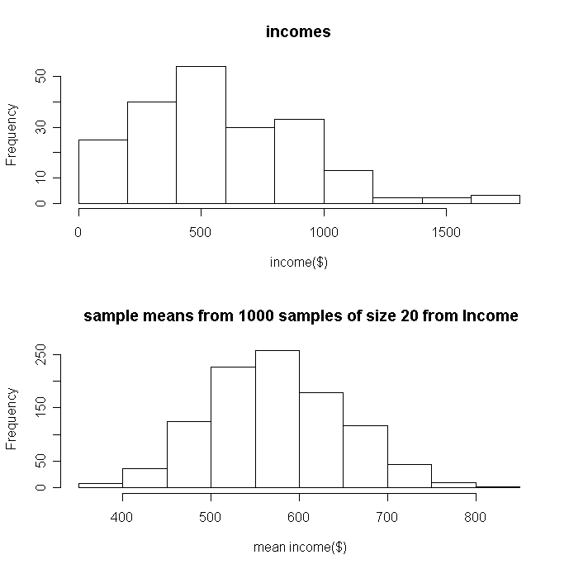

- Discuss any differences between the shapes of the two histograms. In particular, consider the centre, spread, and shape of the two histograms.

- Which of the two histograms does the shape of the stem-and-leaf plot of your class’s sample means resemble? Is that what you expected?

- In the following two statements, copy your random sample mean from Question 1 and insert it below, then circle the correct option in each case, i.e. parameter or statistic.

The population mean income of $524.23 is a parameter/statistic.

The mean weight of my random sample of 20 incomes is $_______ and is a parameter/statistic.

- If another person were to take a random sample of 20 incomes, between what two values do you think their sample mean is likely to lie?

On the next page are the incomes of 200 people of various ages. Each person has been labelled with a number between 1 and 200. The PERSON column in the table below contains the person label while the column immediately to its right contains the income (in $) of the corresponding person.

Note: The mean and standard deviation of the weights of all 200 incomes are $575.36 and $346.61

person | Income |  | person | Income |  | person | Income |  | person | Income
1 | 87 |  | 51 | 264 |  | 101 | 874 |  | 151 | 1099
2 | 596 |  | 52 | 949 |  | 102 | 972 |  | 152 | 255
3 | 497 |  | 53 | 143 |  | 103 | 609 |  | 153 | 496
4 | 299 |  | 54 | 474 |  | 104 | 710 |  | 154 | 724
5 | 301 |  | 55 | 708 |  | 105 | 1131 |  | 155 | 431
6 | 1614 |  | 56 | 112 |  | 106 | 868 |  | 156 | 819
7 | 201 |  | 57 | 525 |  | 107 | 392 |  | 157 | 849
8 | 934 |  | 58 | 849 |  | 108 | 517 |  | 158 | 1152
9 | 624 |  | 59 | 24 |  | 109 | 517 |  | 159 | 525
10 | 533 |  | 60 | 85 |  | 110 | 532 |  | 160 | 463
11 | 609 |  | 61 | 231 |  | 111 | 106 |  | 161 | 884
12 | 620 |  | 62 | 544 |  | 112 | 110 |  | 162 | 700
13 | 371 |  | 63 | 462 |  | 113 | 249 |  | 163 | 409
14 | 404 |  | 64 | 239 |  | 114 | 11 |  | 164 | 437
15 | 623 |  | 65 | 1543 |  | 115 | 835 |  | 165 | 439
16 | 616 |  | 66 | 548 |  | 116 | 925 |  | 166 | 45
17 | 856 |  | 67 | 18 |  | 117 | 950 |  | 167 | 232
18 | 708 |  | 68 | 552 |  | 118 | 860 |  | 168 | 781
19 | 743 |  | 69 | 556 |  | 119 | 425 |  | 169 | 506
20 | 386 |  | 70 | 266 |  | 120 | 244 |  | 170 | 442
21 | 999 |  | 71 | 286 |  | 121 | 830 |  | 171 | 1147
22 | 74 |  | 72 | 1157 |  | 122 | 562 |  | 172 | 156
23 | 387 |  | 73 | 480 |  | 123 | 1145 |  | 173 | 62
24 | 44 |  | 74 | 979 |  | 124 | 193 |  | 174 | 801
25 | 535 |  | 75 | 475 |  | 125 | 515 |  | 175 | 867
26 | 260 |  | 76 | 507 |  | 126 | 259 |  | 176 | 282
27 | 895 |  | 77 | 107 |  | 127 | 99 |  | 177 | 425
28 | 368 |  | 78 | 815 |  | 128 | 757 |  | 178 | 564
29 | 559 |  | 79 | 240 |  | 129 | 952 |  | 179 | 323
30 | 526 |  | 80 | 567 |  | 130 | 1097 |  | 180 | 759
31 | 1084 |  | 81 | 477 |  | 131 | 105 |  | 181 | 161
32 | 628 |  | 82 | 662 |  | 132 | 743 |  | 182 | 863
33 | 383 |  | 83 | 1005 |  | 133 | 218 |  | 183 | 375
34 | 713 |  | 84 | 642 |  | 134 | 94 |  | 184 | 455
35 | 599 |  | 85 | 985 |  | 135 | 390 |  | 185 | 706
36 | 450 |  | 86 | 501 |  | 136 | 805 |  | 186 | 264
37 | 395 |  | 87 | 460 |  | 137 | 902 |  | 187 | 614
38 | 532 |  | 88 | 86 |  | 138 | 406 |  | 188 | 132
39 | 447 |  | 89 | 287 |  | 139 | 1034 |  | 189 | 288
40 | 795 |  | 90 | 102 |  | 140 | 868 |  | 190 | 581
41 | 809 |  | 91 | 630 |  | 141 | 658 |  | 191 | 172
42 | 309 |  | 92 | 402 |  | 142 | 521 |  | 192 | 227
43 | 1217 |  | 93 | 406 |  | 143 | 1099 |  | 193 | 927
44 | 426 |  | 94 | 1062 |  | 144 | 540 |  | 194 | 746
45 | 222 |  | 95 | 108 |  | 145 | 967 |  | 195 | 485
46 | 508 |  | 96 | 220 |  | 146 | 1163 |  | 196 | 386
47 | 351 |  | 97 | 615 |  | 147 | 211 |  | 197 | 1789
48 | 206 |  | 98 | 820 |  | 148 | 539 |  | 198 | 1558
49 | 826 |  | 99 | 626 |  | 149 | 741 |  | 199 | 230
50 | 1724 |  | 100 | 1373 |  | 150 | 768 |  | 200 | 954
Exploring confidence Intervals

A Incomes
1 Referring back to your work on incomes
(a) Do the assumptions for calculating a confidence interval for the mean income appear to have been met?

(b)

(your) Sample Mean ________________

population Standard Deviation _____________

2 Use your sample mean to calculate a 90% confidence interval for the mean income

90% Confidence Interval for the mean ____________________________

Draw your confidence interval as a horizontal line on the grid on the next page. Add those for 5 others. Think carefully about scale on axes.

Add your confidence intervals to the class graph.

5 Conclusions

What percentage of the class confidence intervals would you expect to enclose $575.36?

How many of the classes confidence intervals include the mean income of $575.76?

What percentage of the class confidence intervals enclosed $575.36?

Explain what we mean by a level of confidence of 90%?

6 Further work

Use your data to calculate a 99% confidence interval and an 80% confidence interval.

Add these two confidence intervals to your grid above

How has changing the level of confidence altered the confidence intervals? Explain the relationship between the level of confidence and the width of a confidence interval.

Confident in a Kiss

based on
Richardson,M. and Haller,S. (2003), Confident in a Kiss? Teaching Statistics 25(1) 6-11

If you toss a chocolate Kiss it will either land on its base (the circular face of the cone) or its side.
It is claimed that if you toss chocolate Kisses 0.35 of the time they will land on their side. Is this true?

Carry out an experiment to check this.

You will need to answer (and justify) the following

- size of your sample
- method of tossing the kisses
- your conclusion
- how confident you are in your conclusion

BOOTSTRAP median R code

##read in the text file incomes and name it income
income<-scan(file="incomes.txt")

median(income) ##calculates the median of the incomes

##takes a random sample of size 10, without replecement and names it sample10
sample10<-sample(income,10,replace=FALSE)
sample10 ##display sample on screen
median(sample10) ##calculate the median of the sample

##set up a vector of length 1000, called bootstrapmedians.
##takes a sample of 10 WITH RPLACEMENT from sample10
##calulates the median of the new sample
## store the median in the bootstrapmedians vector
bootstrapmedians<-rep(NA,1000)
for (i in 1:1000){
bootstrapmedians[i]<-median(sample(sample10,10,replace=TRUE))
}

hist(bootstrapmedians) ##histogram of medians

## find 5% and 95% percentiles and store in vector interval
interval<-quantile(bootstrapmedians,probs=c(0.05,0.95))
interval ## display the vector 'interval'

##histogram of medians with 95% confidence interval shown
hist(bootstrapmedians)
segments(interval[1],0,interval[1],400, lty=2,col=2)
segments(interval[2],0,interval[2],400,lty=2,col=2)

Walking Age example – R code

walkage<-read.table(walk.txt,fill=TRUE)
walkage

stem(walkage[1])
stem(walkage[2])

mean(walkage[1])
mean(walkage[2],na.rm=TRUE)
samplediff<- mean(walkage[2],na.rm=TRUE)-mean(walkage[1])

##randomisation

##create vector of all the ages
allages<-c(walkage[,1],walkage[1:10,2])
sumall<-sum(allages)

diffmeans<-rep(NA,1000)
for (i in 1:1000){
thissample<-sample(allages,10)
othermean<-(sumall-sum(thissample))/12
diffmeans[i]<-mean(thissample)-othermean
}

interval<-quantile(diffmeans,probs=c(0.025,0.975))
interval ## display the vector 'interval'

##histogram of medians with 95% confidence interval shown
hist(diffmeans)
segments(interval[1],0,interval[1],400, lty=2,col=2)
segments(interval[2],0,interval[2],400,lty=2,col=2)

##bootstrap
diffmeans<-rep(NA,1000)
for (i in 1:1000){
meana<- mean(sample(allages,12,replace=TRUE))
meanb<- mean(sample(allages,10,replace=TRUE))
diffmeans[i]<-meanb-meana
}
interval<-quantile(diffmeans,probs=c(0.025,0.975))
interval ## display the vector 'interval'

##histogram of medians with 95% confidence interval shown
hist(diffmeans)
segments(interval[1],0,interval[1],400, lty=2,col=2)
segments(interval[2],0,interval[2],400,lty=2,col=2)

