Assessing confidence in confidence intervals



Anna Martin
Avondale College
mar@avcol.school.nz

Key sources of information used:

Statistical Literacy, Reasoning, and Thinking: A Commentary
Robert C. delMas
University of Minnesota
Journal of Statistics Education Volume 10, Number 2 (2002)

Tools for teaching and assessing statistical inference
http://www.tc.umn.edu/~delma001/stat_tools/tools_conf_intv.htm#MISCONCEPTIONS

Data-driven approach

According to Wikipedia, the average word length in the English language is 6.

I wonder what the average word length is of words used in newspaper articles?

New Zealand reading skill takes a drop

Friday November 3, 2007- NZ Herald
By Alanah May Eriksen

The reading performance of New Zealand primary school children has dropped from 13th to 24th in the world in an international study.
The Progress in International Reading Study, issued yesterday, involved children aged about 10 in 40 countries.
Russia, Hong Kong and Singapore were the top three countries.
English children's reading performance also fell, from third to 19th.
But despite dropping on the list, New Zealand students have maintained a consistently high standard of reading in the past five years.
Their average reading score was 532, higher than the study's international average of 500.
The average score for New Zealand students in the first study in 2001 was also high, at 529.
New Zealand girls continued to do better than boys in the latest study, following a worldwide trend. Females had an average score of 544 and males an average of 520.
The study takes information from pupils, parents and teachers.
It is done every five years - data for the latest study was gathered last year - to measure literacy and gather information about home and school factors associated with learning to read. Nearly 2500 New Zealand students from 156 schools were tested in the survey.

1 | 2 | 3 | 4 | 5 | 6 | 7 | 8 | 9 | 10 | 11 | 12 | 13 | 14 | 15

Based on this sample of _______ words, we would estimate the average word length to be __________ letters. The sample standard deviation for the word length is _______ letters.

Constructing a 95% confidence interval, we get an interval of __________________________ for the actual average word length of words used in newspaper articles.

Applying this learning to another context

As children learn to read, the words they know how to read get bigger and bigger.

Sarah is in charge of labelling books at the local library with an appropriate difficulty sticker. She refers to the chart below to determine the difficulty sticker

Average word length Colour of sticker
3 - Pink
5 - Yellow
7 - Black

Describe how Sarah could use a statistical process to determine which sticker to place on each book in the library. Assume that she will use the most difficult sticker on a book if she has a choice.

Example – NZQA Scholarship Statistics 2006

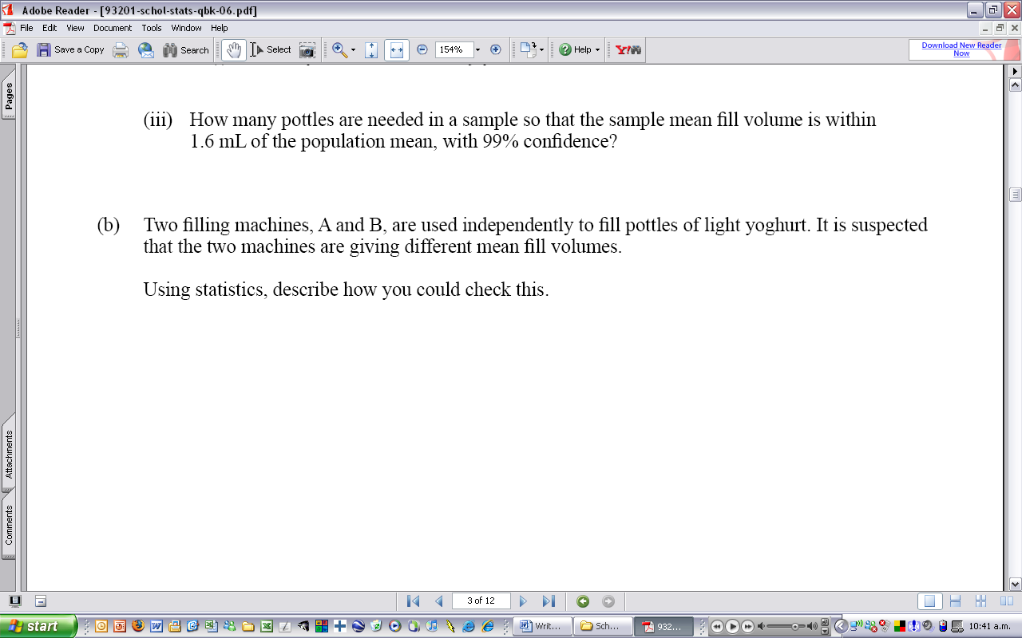

Problem Are the two machines are giving different mean fill volumes?

Plan Take a random sample of 30 pottles of light yoghurt from each of the two machines.

Data Measure the volume of yoghurt in each of the pottles in each of the two samples (either in grams or ml).

Analysis Calculate the mean and standard deviation for each of the two samples of light yoghurt.

Construct a 95% confidence interval for the difference between two population means (μ_{A} – μ_{B}), using the sample standard deviation as an estimate for the population standard deviation.

Conclusion If zero is not in the confidence interval obtained, then there will be evidence that the two machines are giving different mean fill volumes. This is because both the lower and upper bounds of the interval will either be both positive (which will suggest machine A is filling more on average than machine B) or both negative (which will suggest that machine B is filling more on average than machine B).

Are students confident with confidence intervals?

NZQA national results

Year | Number of students A or higher | Achievement | Merit | Excellence
2004 | 10 237 | 40.9 | 53.9 | 5.2
2005 | 10 406 | 41.1 | 51.8 | 7.0
2006 | 10 775 | 67.3 | 28.4 | 4.3

The 2006 examination paper contained TWO questions that required students to interpret confidence intervals in response to a claim about the population parameter. Is it a co-incidence that the proportion of Merit and Excellence grades declined?

But even in previous years (2004 – 2005), is the high proportion of Merit and Excellence grades evidence that students understand confidence intervals?

What does it mean to understand confidence intervals? And how do we assess understanding in confidence intervals? What are the different thinking and reasoning skills needed to understand confidence intervals?

- We have focused on what students can DO with and SAY about confidence intervals as a measure of their understanding
- We have given students sentences they can memorise that match different outcomes (e.g. zero is in the interval – zero is not in the interval ☺)
- We have not always checked to see if students have misconceptions of confidence intervals

The role of assessment

Assessment is key component of any learning programme.

What we assess should reflect what we value in statistical eduaction as well as what is required by external standards (such as NCEA, CIE or Scholarship).

Assessment can be used to determine the level of understanding a student has as well as whether they have any misconceptions.

Why confidence intervals?

Cover general approach to writing/analysing questions that focus on statistical reasoning and thinking.

Confidence intervals is a nice topic with a lot of scope for extension and misunderstandings!

My personal experience with students is that they can perform calculations, manipulate the formulae to find unknowns (including sample size) and remember “interpretations” but lack confidence in unfamiliar situations that require thinking and can’t apply principles of confidence intervals or sampling distributions to solve a problem set in a practical context.

NCEA Achievement Standard - 90642

This achievement standard involves calculating confidence intervals for population parameters from large samples.

 | Achievement Criteria | Explanatory Notes
Achievement | - Calculate confidence intervals for population parameters. | - Population parameters for which confidence intervals are calculated will be selected from:  - mean  - proportion  - difference between two means.
Achievement with Merit | - Demonstrate an understanding of confidence intervals. | - This will include some of:  - interpreting confidence intervals  - justifying or refuting claims about a  population parameter  - calculating the sample size required to  meet a pre-specified precision  - estimating population totals.
Achievement with Excellence | - Demonstrate an understanding of the theory behind confidence intervals. | - The understanding may involve:  - effect of changing parameters on the precision or standard error  - applications of the Central Limit Theorem,  - distribution of sample means  - distribution of sample totals  - use of probability including normal distribution.

NB: The use of appropriate technology is expected.
What do we want students to understand?

A confidence interval is an interval estimate of an unknown population parameter (e.g. the population mean), based on a random sample from the population.

A confidence interval is a set of plausible values of the parameter that could have generated the observed data as a likely outcome.

A confidence interval consists of a sample statistic plus or minus a measure of sampling error (which is error from random sampling), when we have approximate normality of the sampling distribution.

The level of confidence tells the probability the method produced an interval that includes the unknown parameter.

The probability relates to the method (data, interval), not to the parameter.

An increase in sample size leads to a decreased interval width: large samples have narrower widths than small samples (all other things being equal).

Higher confidence levels have wider intervals than lower confidence levels (all other things being equal).

Narrow widths and high confidence levels are desirable, but these two things affect each other.

If many random samples are independently sampled from a population and 95% confidence intervals constructed for each one, we would expect about 5% intervals to not include the population parameter. This 95% refers to the process of taking repeating samples and constructing confidence intervals for each.

A confidence interval suggests what parameter values are reasonable given the data and all values in the interval are equally plausible as values that could have produced the observed sample statistic.

After you calculate one confidence interval, the parameter is either included or not, but you don't know.

It is desirable to have a narrow width (for more precise estimates) with a high level of confidence. A narrow width alone is not sufficient (if it has a low level of confidence).

Is there anything else?

Confidence intervals and levels of understanding

Statistical thinking

Students use knowledge, skills and reasoning in context to apply their understanding to real world problems. They can critique and evaluate the design and conclusions of studies, or generalise knowledge obtained from classroom examples to new situations.

Statistical reasoning

Students can explain why or how results were produced or why a conclusion is justified. This is based around their understanding of the statistical processes or methods and does not need to be set in context e.g. How does the size of the sample affect the width of the confidence interval?

Statistical literacy

Students can identify examples or instances of a term or concept, describe graphs, distributions, and relationships, rephrase or translate statistical findings, or interpret the results of a statistical procedure. For confidence intervals, this could be computing confidence intervals and correctly writing the interval in an accepted form of notation.

Identifying misunderstandings

Correct understanding:

A confidence interval is an interval estimate of an unknown population parameter (e.g. the population mean), based on a random sample from the population.

Common misunderstanding:

The confidence interval gives information about likely individual values of the population.

Why might students have this misunderstanding?

Normal distribution probability calculations. Confusion between population distribution and sampling distibution.

How could we assess for this misunderstanding?

Mr Huppard wants there to be at least 50 grams of fruit in 95% of the cereal packets that get produced. He takes a random sample of 45 cereal packets and finds that the average weight of fruit in the packets was 65 grams. He remembers something about confidence intervals from school and calculates an 95% confidence interval for the population mean to be between 55 < μ < 75 grams.

Is Mr Huppard’s target that there is at least 50 grams of fruit in 95% of the cereal packets being produced being met? Explain your answer fully.

Identifying misunderstandings

Correct understanding:

All values in the confidence interval are equally plausible as values that could have produced the observed sample statistic.

Common misunderstanding:

That values at the ends of the interval are less likely to be the population parameter than those in the middle of the interval.

Why might students have this misunderstanding?

The normal distribution is bell-shaped.
Confidence intervals is something to do with the normal distribution.

Maybe they view confidence intervals rather than this:
like this:
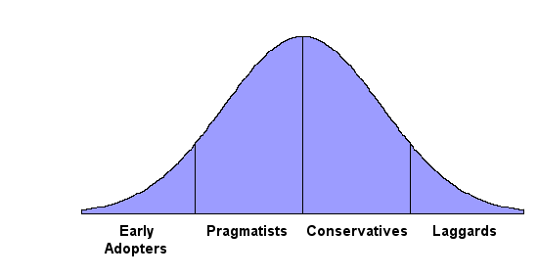

|----------------------------|

20 < μ < 25 20 < μ < 25

How could we assess for this misunderstanding?

The Board of Trustees of a school is concerned with the high level of absenteeism. They have asked the Principal to investigate the problem and they will take action if there is, on average, 100 students per day absent.

The Principal randomly selected 30 school days over a three month period and obtained the number of students absent for at least half the day. For his sample, he calculated a mean of 93.4 students and a standard deviation of 21.9.

The principal constructs a 95% confidence interval for the actual average number of students absent per day and obtains the following interval:

85.6 < μ < 101.2

He goes to the Board of Trustees and says that, as the upper limit of the confidence interval is only just over 100, it is not likely that the average number of students absent per day is 100.

Is he valid in interpreting the confidence interval like this? Fully explain your answer.

Alternative but related approaches to confidence intervals

Anna wants to know if Mathematics teachers support the name change of the curriculum to Mathematics and Statistics.

She obtained a random sample of 42 Mathematics teachers. Anna found that 24 of these 42 teachers support the name change.

Anna says that this shows that the majority of Mathematics teachers support the name change because 57.1% of those sampled support the name change.

Discuss the validity of Anna’s claim that the majority of Mathematics teachers support the name change.

What thinking processes do we want students to work through?

- Does the sample meet the conditions that allow us to construct confidence intervals?
- 57.1% is higher than 50% but is it high enough?
- 57.1% is based on one sample from the population and we know that samples vary.
- Just because Anna got 57.1% for this sample, she may get a higher or lower value for another sample.
- Should construct a confidence interval to give a range of possible values for the population proportion.
- Compare this confidence interval to 50%, if the lower limit is greater than 50%, then Anna can conclude that the majority of Mathematics teachers support the name change. Otherwise, she will not have enough evidence to back up this claim.

What else could they think?

- If 50% of Mathematics teachers supporting the name change, so not a majority, could Anna have got a sample proportion of 57.1%?

- How likely is it to get at least 24 out of 42 teachers who support the name change if only 50% of Mathematics teachers support the name change?

From dot plots to box plots to confidence intervals

Mr Clueless was interested in the sugar content of two different kinds of soft drink. He took random samples of 30 bottles (500ml) from supermarkets around Auckland and measured the amount of sugar in each bottle. Unfortunately, he got his results mixed up and now doesn’t know which type of soft drink the samples are from.

Below is given to such samples, where the measured variable is the amount of sugar (grams) in one 500ml bottle of soft drink.

Sample 1:

25, 24, 28, 24, 45, 21, 22, 20, 40, 29, 35, 34, 33, 25, 19, 28, 24, 42, 23, 29, 30, 31, 25, 35, 38, 30, 29, 27, 48, 25

Sample 2:

53, 41, 74, 72, 38, 81, 54, 10, 40, 92, 31, 94, 23, 43, 29, 32, 44, 72, 23, 63, 64, 58, 35, 55, 62, 50, 72, 91, 58, 45

Do you think that these two samples are of the same type of soft drink?
Explore the data provided by constructing appropriate graphs and calculating appropriate statistics. Present and discuss evidence that supports your answer.

Dot plots

Sample 1
Sample 2
25 30 35 40 45 50 55 65 70 75 80 85 90 95

Confidence intervals
Sample 1
Sample 2

