Lunchtime Liaisons.

This workshop is designed to encourage, by demonstration, the use of a probability simulation to give students a view of how changing the sample size affects the variability.

You will each get a disk in the pack and this disk contains all of the files, including the simulation (which runs in Microsoft office 2003).

When you come to open the simulation on your computer, just be aware that a warning will come up asking if you want to block the “unsafe expressions”.

The correct answer to this is “No”. The “unsafe expressions” are quite safe, they are in fact the probability simulation code and not some horrible computer virus, so no need to fear. After you push “No”, Click on “Open” and then on “LunchLiaisons”.

Also if you hit the “Clear Data Recorded” button, just click “yes” twice afterwards on the warning windows that pop up.

Don’t try to run the simulation from the disk. Copy the whole folder to your hard drive first.

The disk also contains the powerpoint presentation that introduces the activity, and the tinkerplot file for those of you who have tinkerplots in your schools.

The following clockface will assist you with the manual simulation:
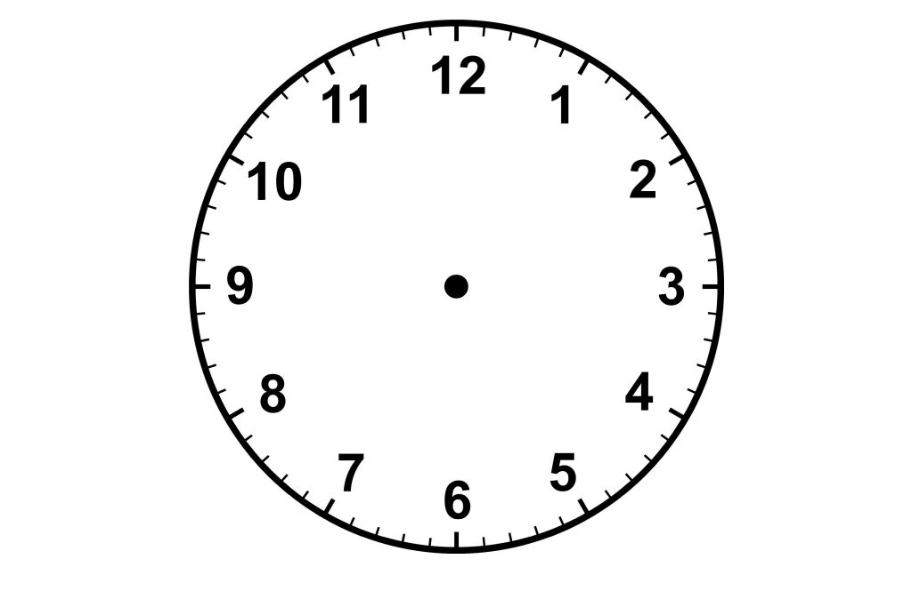

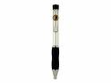
Open the paperclip to this shape:

Place it in the centre of the clock and put the point of your pen at the centre to make a spinner to generate a random time during lunchtime.
SIMULATION WITHOUT COMPUTER:

Lunchtime Liaisons?

Trial Number | Rod’s Arrival time | Rachael’s Arrival time | Do they meet? | How many meetings so far?
1
2
3
4
5
6
7
8
9
10
11
12
13
14
15
16
17
18
19
20

PROBABILITY OF MEETING = TOTAL NUMBER OF MEETINGS20

= ________

PERCENTAGE OF THE TIME THEY EXPECT TO MEET:

= _________%

