IWBNET conference in Australia is a MUST to attend if PD budget allows! Next one (5th National IWB Conference is in Melbourne in August 2008). Check www.iwbnet.net.au for details.

SOME WEBSITES THAT YOU MIGHT FIND USEFUL

FREEWARE that you may find useful.

1. I forgot to show you TEN QUICK QUESTIONS. This is a brilliant piece of software for the “manic minute” or whatever you would like to call it. The free download works perfectly well and the students love it. Suitable for Y9 and Y10 students (and possibly for some skill sharpening for higher levels!). Has plenty of topics. Each topic has ‘subtopics’ and there are ten questions in each topic. Answers are displayed at the end of the ten questions. You can change the length of the test by going into setup.

Website http://www.csfsoftware.co.uk/TQQs_info.htm
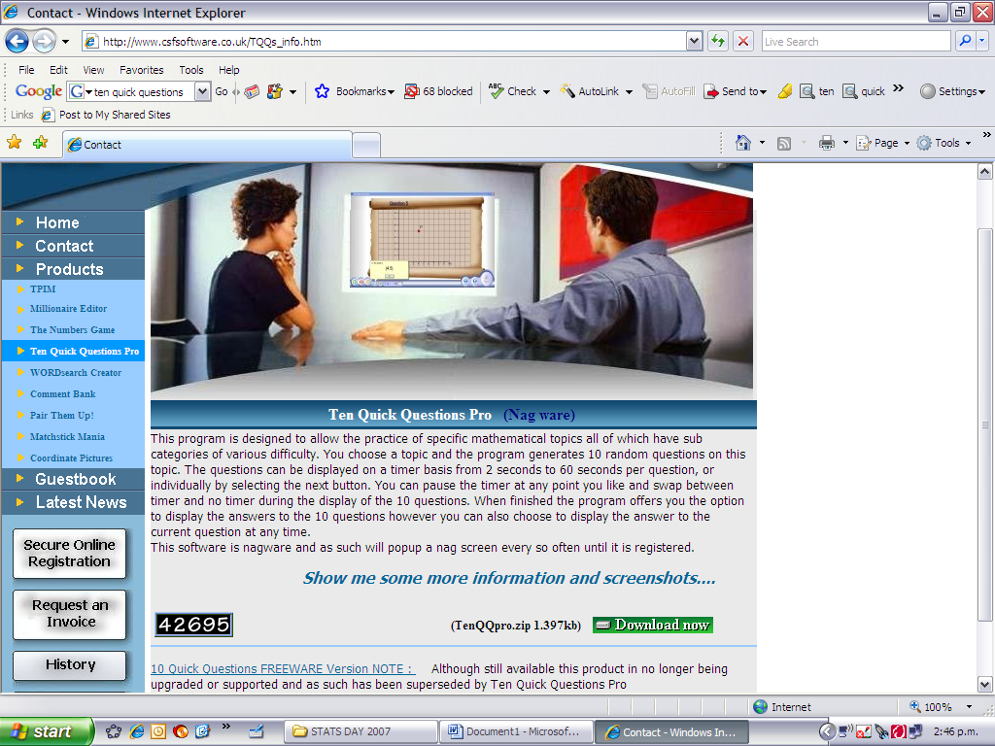

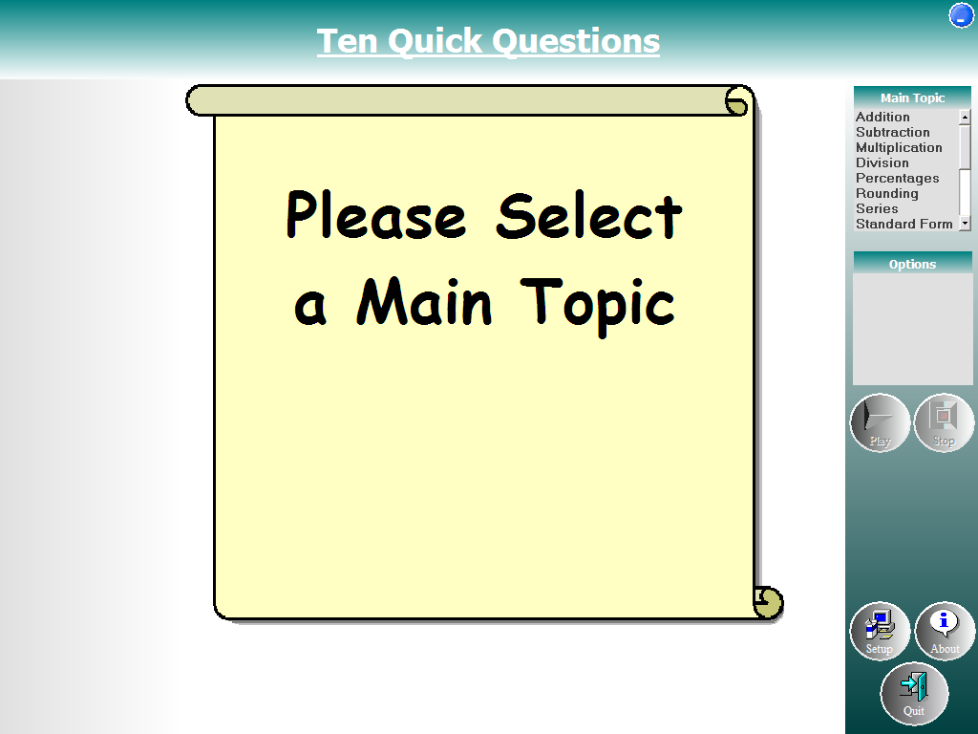

- FREE graphing software. www.geogebra.org

Learned about this at the IWBNET conference in September. I have only just started playing with it and have found it to be extremely useful for all levels. Useful for graphs and for transformation geometry. Copies to clipboard really easily so pasting into another file is exceptionally easy.

WEBSITES
http://noppa5.pc.helsinki.fi/koe/flash/corr/ch16.html
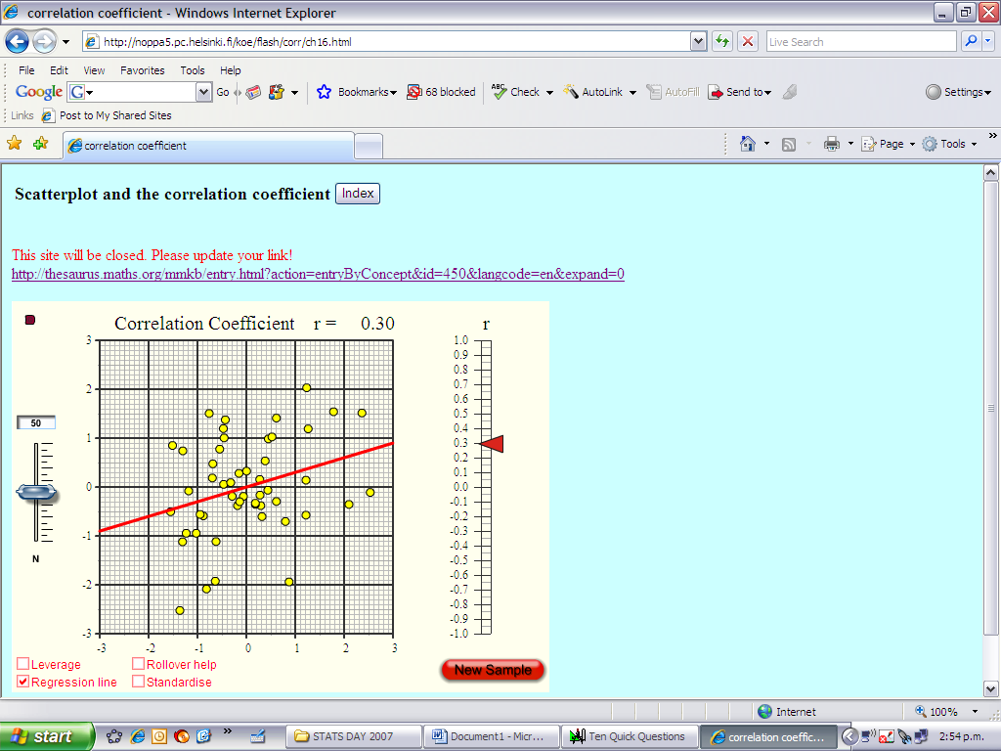
Correlation: Showing the effect of changing the scatterplot on the value of ‘r’. When you go into the website it will look as though the website is closed but the applet still works. (Well it does today on 3rd Dec 2007!)

http://illuminations.nctm.org/LessonDetail.aspx?ID=L454#first

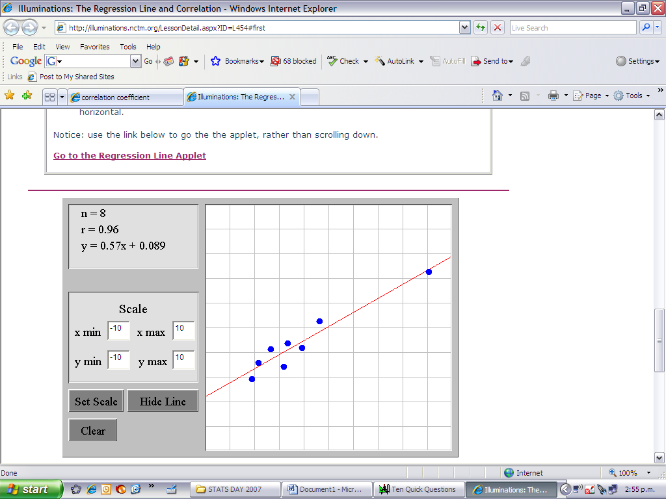
Applet showing how points affect the correlation coefficient. Brilliant for showing outliers and how they affect r (so obviously we can look at the effect of outliers on R squared then too).

http://illuminations.nctm.org/ActivityDetail.aspx?ID=146

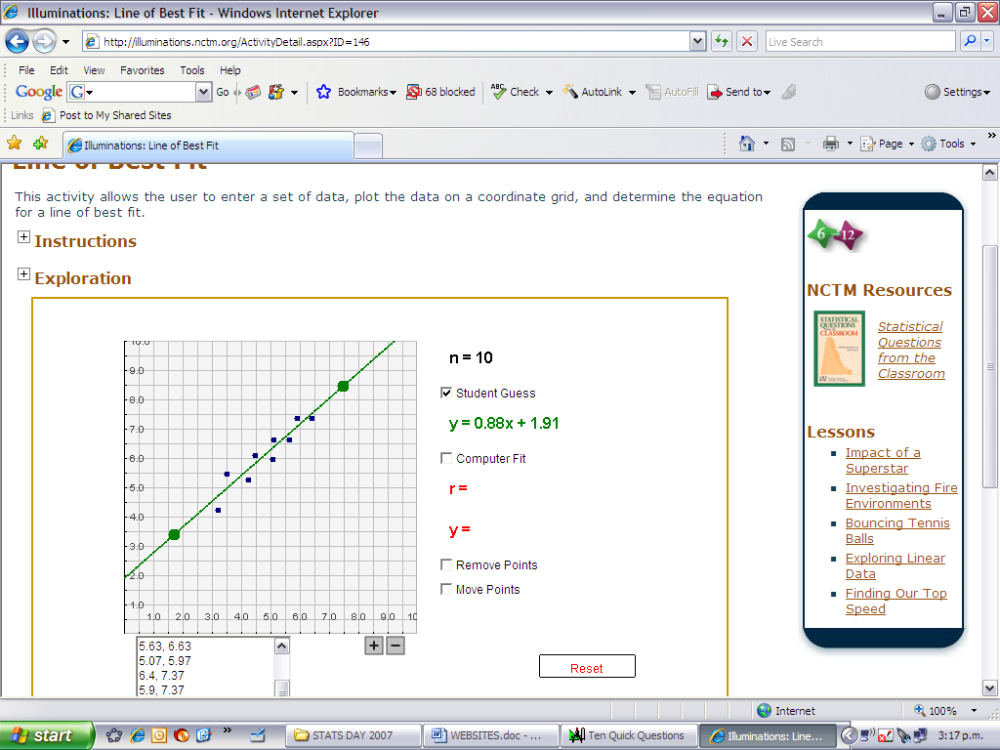
Applet where students can enter points (just click on to add points), guess where the line of best fit should be and then compare their guess to the actual line of best fit.

http://www.ruf.rice.edu/~lane/stat_sim/sampling_dist/index.html

Applet showing the sampling distribution of a variety of sample statistics is normally distributed regardless of the original distribution.

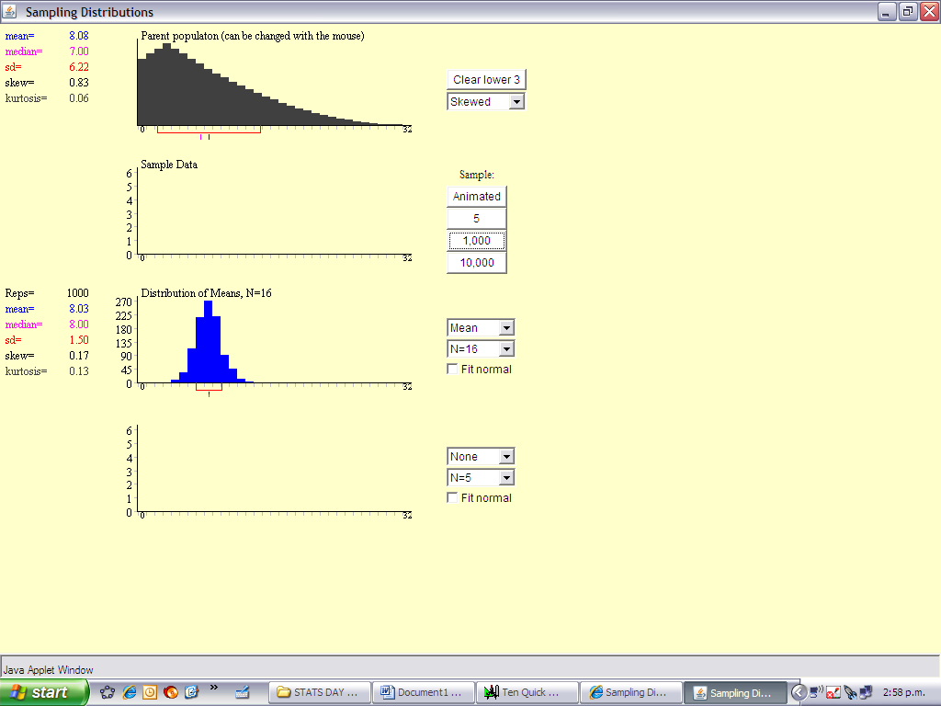

http://www.srl.gatech.edu/education/ME2016/NumMeth/

Excellent for showing the Newton Raphson method.

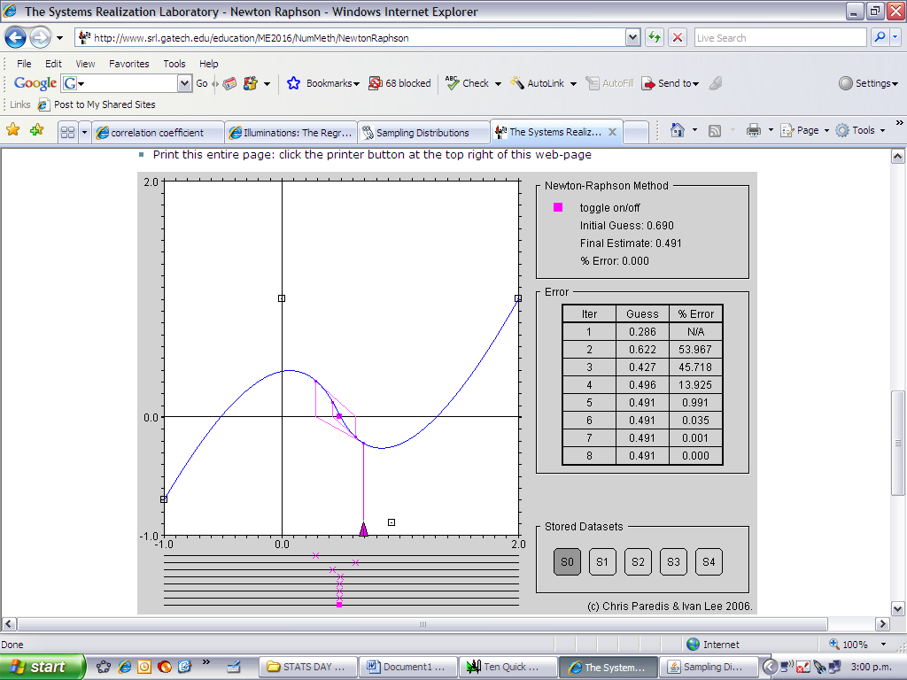

http://www.math.csusb.edu/faculty/stanton/m262/regress/regress.html

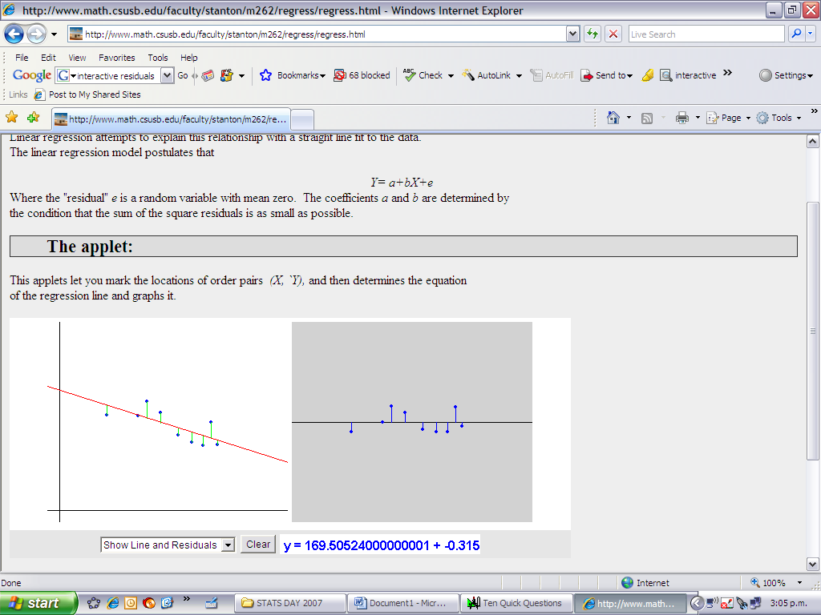
Applet for discussion of residual analysis

