Growing Scatterplots
Level 4-6
Focus: growing scatter plots
Before the problem is created some background information is needed about the data that is available. This is activity is useful for the first time scatterplots are introduced to students.

This activity uses six different sets of data cards. Each set of data cards contains a sample of 40 Year 9 students selected at random from the Census at School database in 2005.

 | Teacher activity/ dialogue | Possible student outcome/dialogue
Problem  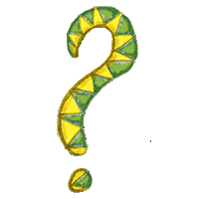 | Hand out the pre-prepared data card sets. Tell the students only that each set is a sample of 40 Year 9 students from the 2005 Census at School database.  Get the students to look at the cards and make notes about what they notice. Split them up by colour.  Explain that each data card is for one person and gives 5 pieces of information about that person. What do you think the pieces of information are?  Draw an outline of the data card on the board and collate ideas.  Complete the outline as the variables are ascertained by the class.  Discuss the variables with the class. What was the survey question that was asked in the Census at School questionnaire for each of the variables?  # gender - 1. Are you: male/female  #circumwrist – What is your wrist circumference? (cm)  #circumneck – What is your neck circumference? (cm)  #year - What year level are you?  # age - 2. How old are you?  Discussion on sample and population. It is worthwhile now having a discussion about the sample of cards they have in front of them. Ask the students to describe what they think the cards represent.  Need to distinguish at this point that we want to use the sample to make decisions about the population.  Brainstorm some investigative questions that could be asked of these samples of data cards about the population.  At this stage accept all questions that are suggested. If the students appear to be suggesting just one type of question, e.g. comparison only, encourage them to come up with summary and relationship type questions. It would be useful to categorise the questions into the three different types.  Refining the investigative questions  It maybe that you might want to explore some of the summary or comparison questions that have been raised by the students. However, this activity is focusing on relationship questions.  At this point we want to take the relationship investigative question that was (possibly) posed.  I wonder if wrist size and neck size are related.  We want to make sure the population we are interested in (i.e. that our sample came from) is reflected in the investigative question. This is the population about which we want to make inferences.  Questioning the investigative question(s)  Can this question be answered by the data you have? Is there sufficient data?  Who would be interested in the outcome of this investigation?  What would be the purpose of the results? | Students should notice:  That the gender is there, boy/girls  That there are numbers on the cards, ,  cards have mostly 2 digit numbers across the middle  That the bottom part of the card has two numbers in it  Hopefully the students will:  -come up with at least the gender  -see that the wrist/neck values, one is twice the other  -guess what the two variables at the bottom might be by the fact that they are repeated on many cards, and 9 is on all of them  wrist/neck card  gender top  wrist circ. left, neck circ. right  year level/age bottom  Survey question: question that was asked to get the data  Investigative question: question that is asked of the data  It is possible that some students will think that they are all from the same class? Probably not with 40, but maybe all from the same school… challenge this notion, 40 students from a total of 33,000. Is it likely that they will even know one another??  What is the population that the sample came from? It is the 2005 Census at School database which contains 33,000 Year 5-10 students from all over New Zealand. Question: does this database represent all Year 5-10 students in New Zealand?  Wrist/neck – I wonder …  - If boys tend to have bigger necks than girls,  - What the typical wrist size is for a year 9 student,  - If wrist size and neck size are related  I wonder if there is a relationship between wrist circumference and neck circumference of Year 9 boys and girls in the 2005 NZ Census at School database.
Plan  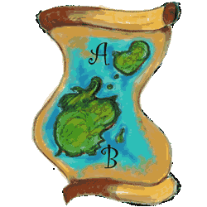 | Once the investigative question is posed and is suitable it is important to get down the key information about the data. This can include but is not limited to:  - Where the data came from  - How many students are in the sample and how the sample was selected  - Gender, age, year level, ethnicity, location as appropriate  - Is this sample a good representation of the population or not  - random sample what is it  - What variables are going to be focused on and what survey questions were asked to collect the data?  What type of graph(s) will be used to display the data? What are you looking for in these graphs? What do you expect to see? | These data are from the 2005 NZ Census at School database. 40 Year 9 students were selected using the random sampler. As the sample is random all Year 9 students had an equal chance of being selected. Students are a mixture of boys and girls. The investigative question focuses on neck and wrist circumference. The survey questions asked to get these data were#circumwrist – What is your wrist circumference? (cm)  #circumneck – What is your neck circumference? (cm)  Will use a scatterplot to look for a relationship. Expect to see some sort of relationship, think as your wrist gets bigger expect neck to too.
Data  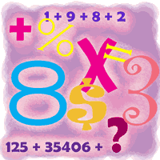 | Data cards are given to groups of students. It maybe that you can use different coloured paper and sort the sets so that boys are one colour and girls are another (for example – to bring in a third variable).  Get the students to look through the cards, checking for any unusual values. Students need to decide if these values are “realistic” or “unrealistic”. Discussion on why/why not and whether they should be kept for the analysis.  The data needs to be cleaned. Reference Level 5.  Students need to think about what values might be appropriate for the different variables (neck and wrist). They can have a look at their cards and discuss any they think are not suitable. It maybe that they need to make these measurements of themselves to see how they really work. | Typical examples of incorrect values – wrist and neck circumference are interesting, anything below 10 cm for wrist is pretty small, get students to check their own and find this out, also neck is roughly double the wrist, this maybe clear from just looking through, some of these will be picked up once the data is graphed.
Analysis  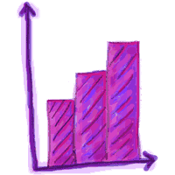 | Next stage is to develop the graph.  Get the students to sort the data cards using the wrist data. They could build a dot plot below the x axis.  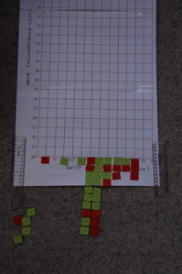  From here grow the scatterplot, move the card from the wrist position to the neck position.  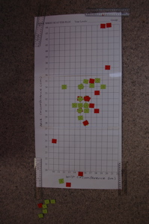  Hope that the students realise as they get higher wrists, they have to move further up, also get to see that for any given wrist there are a number of different neck circumferences, leading to the idea that when making predictions there isn’t one right value. | This picture shows the data cards with the wrist values sorted below the x axis. Cards in the bottom left are those that are not realistic so have been left out of the analysis.  This picture shows the data cards placed in position. There is a group of cards at the bottom that were unrealistic. Students should write about which cards they didn’t use and why.  When I made the dot plot of wrist circumferences I didn’t include five cards because the values of the wrists were too small. They were 3.5, 5.5, 5.7,6 and 6. When I made the scatterplot I excluded another four cards. 15/10 and 16.5/12 as the neck was smaller than the wrist, 20/0 as there was no neck measurement and 15/20 as that just didn’t seem realistic. I had noticed that neck was about double the wrist.
 | 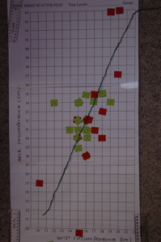  Get the students to place a piece of string to show the pattern of the data. | This picture shows the pattern of the data placed on top.  Data cards can be glued to the graph and the graphs placed on the wall. In addition the pattern can be cellotaped onto the graph.  Remember that there are six different samples so there will be slightly different pictures of the data.
 | Assuming this is possibly the first time students have really been focused on relationship questions get them to write down things they noticed as they created their graphs. They should note down their ideas.  You may like to use two further pieces of string to indicate the spread.  Get the students to walk around and look at other graphs that other students have made. Get them to compare and contrast the other graphs with their graph. | Things they might notice include:  - That the smaller the neck the smaller the wrist circumference  - That there are lots of wrist and neck sizes the same  - Some of the data cards were “invalid” indicating incorrect measurements  - That the data cards seem to follow a pattern.
Conclusion   | These data suggest that there appears to be a relationship between wrist and neck circumference. There is an upward pattern in the plot, which means that people with bigger wrists tend to have bigger necks. The relationship is quite strong as this pattern is quite clear. Neck circumference appears to be twice the wrist circumference.
Reflection | What is the difference between the investigative question and the survey question?  What were the benefits of growing the scatterplot? Do you think you need to do this more times for the students to get a good picture/idea of the relationship idea that a scatterplot shows?
Extension activity

Describing Scatterplots
Level 6
Focus: Describing scatterplots
This resource contains 15 pages of scatterplots. Most have a short story with the variables listed and the data set given. This is usually on one page. On a second page are the title, variables and then the scatterplots. With each graph(s) there is the starter: What we notice about the graph(s):

The main aim of this activity is to get students to describe what they see in the graphs before they get hung up on drawing lines of best fit, making calculations or in fact have much in the way of analysis tools. Trying to get through to them the need to draw the graph first.

Plan | Photocopy the pages for use in class. The write-on pages need to be copied multiple times, the story pages only once. Make about eight copies of each write-on page. (64 activities, standard class 15 pairs @ 4 each is 60 activities)  Set up the different stories around the class. Split the class into pairs. Each pair should endeavour to do at least 4 different stories. (allow about 5 mins per story then move to next one)  Suggested groupings might be:  Pair 1 do 1, 2, 3, 4 Pair 2 do 2, 3, 4, 1  Pair 3 do 2, 3, 4, 5 Pair 4 do 3, 4, 5, 2  Pair 5 do 3, 4, 5, 6 Pair 6 do 4, 5, 6, 3  Pair 7 do 4, 5, 6, 7 Pair 8 do 5, 6, 7, 4  Pair 9 do 5, 6, 7, 8 Pair 10 do 6, 7, 8, 5  Pair 11 do 6, 7, 8, 1 Pair 12 do 7, 8, 1, 6  Pair 13 do 7, 8, 1, 2 Pair 14 do 8, 1, 2, 7  Pair 15 do 8, 1, 2, 3 Pair 16 do 1, 2, 3, 8  At the end the pairings will join up to compare and contrast what they have found (that is why the pairs are not doing the same activity at the same time).  Pair 1 and 2 together etc.  Any additional pairs double up.
Data | - Smoking and cancer (2 pages – 1 write-on)  - World population figures (2 pages – 1 write-on)  - Olympic games long jump gold medal (2 pages – 1 write-on)  - High jump world records men (2 pages – 1 write-on)  - Global mean temperatures (3 pages – 1 write-on)  - Alligator (1 write-on page)  - Cattle (1 write-on page)  - Body fat (2 pages – 1 write-on)
Analysis | Focus in this activity is on the analysis of the graph, initial not icing’s that students do.  Get pairs of students to compare and contrast with another pair of students who have done the same activity.
Conclusion

Reflection
Extension activity
ANALYSIS AND CONCLUSIONS

Analysis
Discussion about box and whisker plots might include the following aspects:

ELEMENTS OF REASONING:
- Hypothesis generation - Compares and reasons about the group trend.
- Summary - Compares equivalent five-number summary points. Compares non-equivalent five-number summary points.
- Shift - Compares one box plot in relation to the other box plot and refers to comparative shift.
- Signal - Compares the overlap of the central 50% of the data.
- Spread - Compares and refers to type of spread/densities locally and globally within and between box plots.
- Sampling - Considers sample size, the comparison if another sample was taken, the population on which to make an inference.
- Explanatory - Understands context of data, considers whether findings make sense, and considers alternative explanations for the findings.
- Individual case - Considers possible outliers, compares individual cases.

MODERATING ELEMENTS OF REASONING: (contained within each of the eight elements above)
9. Evaluative - Evidence described, assessed on its strength, weighed up.
10. Referent - Group label, data measure, statistical measure, data attribution, data plot distribution, contextual and statistical knowledge.

Maxine Pfannkuch 2006, Statistics Education Research Journal 5(2) 27-45
At level 5 it is suggested that students start to look at the summary, shift/signal and spread view. “You should compare summary statistics, shape of the data, spread of the data and the middle 50% of the data.” – from post test.

Conclusions
A fully rounded conclusion by Year 13 might include the following aspects:

- Support (or otherwise) for the hypothesis
- Quantification of the conclusion
- Generalisation of the sample findings to the target population, which is defined clearly
- Discussion on the constraints of the experiment (constant variables, definitions of what was measured – qualifies the findings)
- Alternative explanations
- Justification for the findings

Megan Jowsey – Masters thesis 2006.
At level 5 in the curriculum it is suggested that the conclusion starts to focus on the initial three points. Support, quantification and generalisation.

Instruction sheet for sheep reaction times.

URL for sheep reaction times: http://www.bbc.co.uk/science/humanbody/sleep/sheep/reaction_version5.swf

Screen that comes up when you first enter the website. Click on the go button to start.

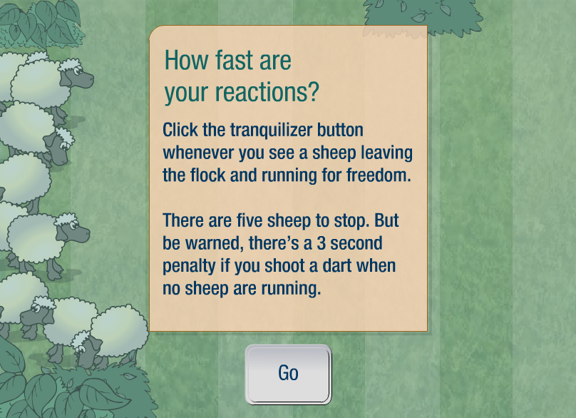

Line up the mouse over the tranquilliser button to stop the sheep. You only need to click the button, not aim at the sheep.

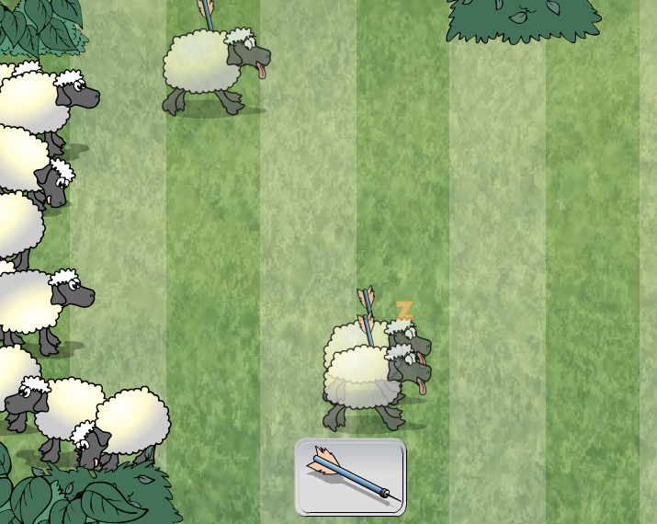

As you are successful at hitting the sheep they stop. After five goes the activity stops and a summary of the five sheep is given along with an average for all five sheep and a description of your ability to react.

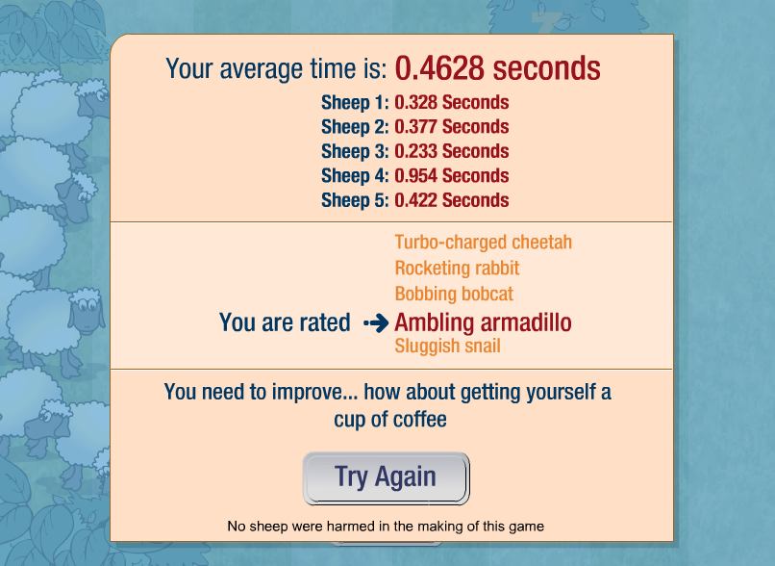

Record the five times beside the sheep in the order that they happen.

Sometimes you might jump the gun. Click on continue and then keep going for the current trial.

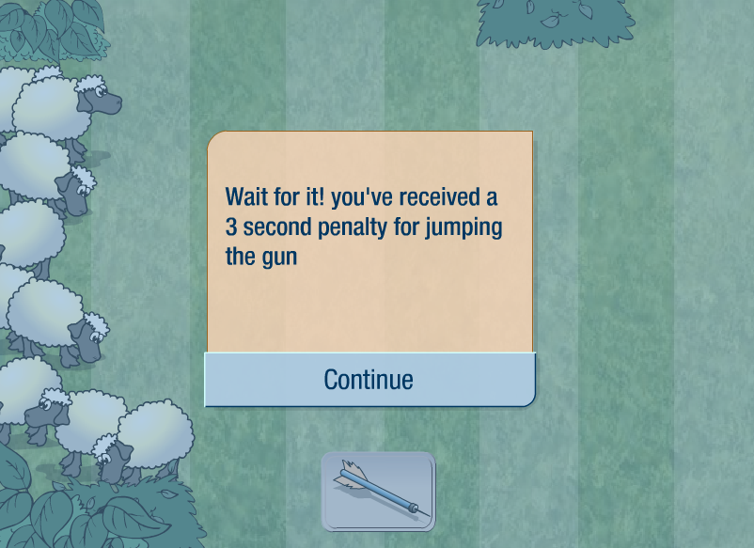

Record results the same as previously, except this time you will have some at 3 seconds depending in how many times you have jumped the gun.

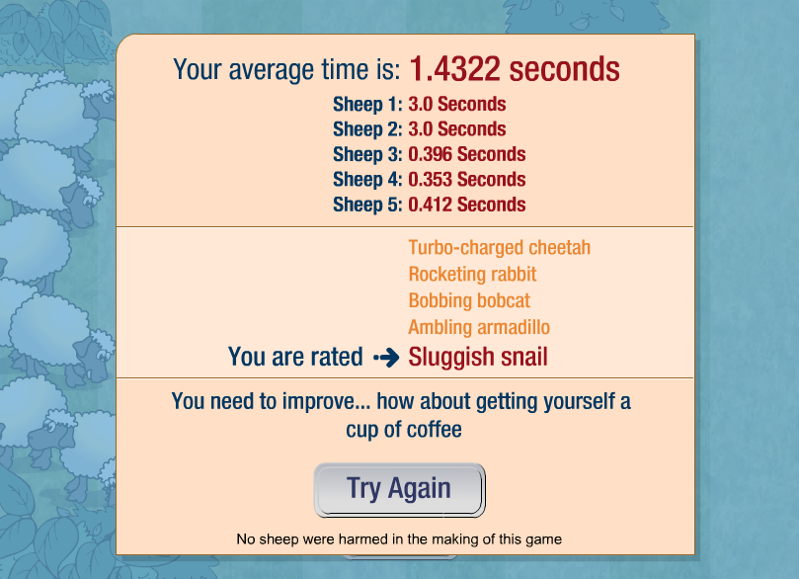

 | Sheep | Average | Description |  |  | Sheep | Average | Description
1 |  |  |  |  | 16
2 |  |  |  |  | 17
3 |  |  |  |  | 18
4 |  |  |  |  | 19
5 |  |  |  |  | 20
6 |  |  |  |  | 21
7 |  |  |  |  | 22
8 |  |  |  |  | 23
9 |  |  |  |  | 24
10 |  |  |  |  | 25
11 |  |  |  |  | 26
12 |  |  |  |  | 27
13 |  |  |  |  | 28
14 |  |  |  |  | 29
15 |  |  |  |  | 30

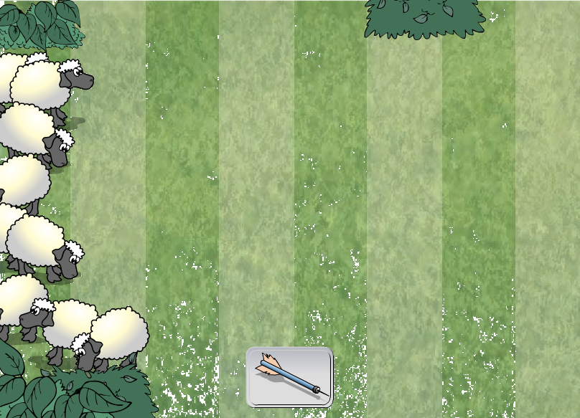

PROBLEM:

PLAN:

DATA:

ANALYSIS:
I notice…

Summary statistics

Shape of data

Spread of the data

Middle 50% of the data

CONCLUSION:
Answer to the question

Supporting evidence

Generalisation (how might these sample findings relate to the population):

Sleeping sheep or are you a turbo-charged cheetah?
Level 6
Focus: comparison
This activity involves using a website shockwave flash activity to collect student reaction times.

Students to design aspects of the investigation within the boundaries.

URL for sheep reaction times: http://www.bbc.co.uk/science/humanbody/sleep/sheep/reaction_version5.swf

Problem | Do I have a faster reaction time than X?  Make a prediction. |  | Why might fast reaction times be important?  Generally, and then specifically in using the computer.
Plan | In this part of the cycle students need to think about how they might test to see who has the faster reaction time.  Things to consider:  How they will measure reaction time – use the sheep reaction time activity.  How many measures will they take?  Will they allow a practice run?  How will they deal with penalty shots?  How do we know everyone has done the same trialling?  It maybe worthwhile to let them have an explore with the activity for five minutes and then discuss further how the experiment might work. Other ideas include giving students extended time to explore the activity and come up with the plan. |  | http://www.bbc.co.uk/science/humanbody/sleep/sheep/reaction_version5.swf provides an interactive shockwave flash activity whereby the players have to tranquilize sheep as they leave the pen. Details on how the game works are below.  In trailing this task, some students just ignored sets of data where they had scored 3.0 penalty times. This meant that it took a little longer but more importantly the data then wasn’t reliable as not everyone had performed under the same conditions.
 | 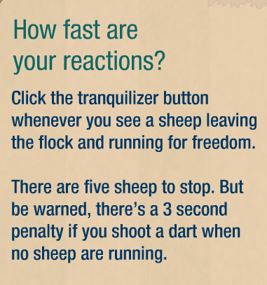
Suggest that they do the activity once just to get a feel for how it works.
Maybe they might collect 30 pieces of data, do the activity 6 times.
At the end of each set of five sheep the reaction times for the five sheep are given.

Data | 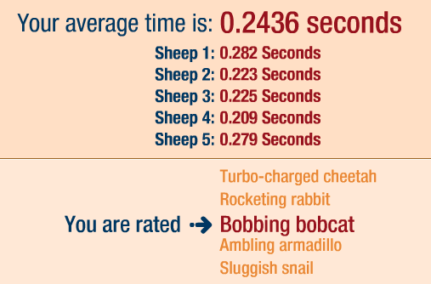 |  | Students to play the game six times and record the five results each time. Total 30 results. It is not necessary to record the average time. Important to keep the trials in order from 1 – 30.  Follow up the data collection with feedback on how they found it. Were there any strategies they employed, e.g. covering the bobbing sheep’s head.
Analysis | Once the students have collected their 30 pieces of data and their friend’s 30 pieces of data they can draw graphs and write descriptions of what they notice.  The first graph to draw is an observation plot. This is simply a time series type graph where the observation number (trial number) is along the x axis and the time taken is on the y axis.  From this observation plot you want to see if there is any pattern to the trials. For example it might be that there is clearly a pattern of improvement, that is with practice the times are improving, or is the plot random, that is there is not an improvement happening so the 30 trials could be considered a sample and therefore it is possible to make a generalisation about the population of interest, which in this case would be the reaction times of the person.  Once the students have had a look at the observation plot and they are happy that the data appears to be a “random” sample of the person’s possible reaction times they can now draw plots to start to compare the two sets of reaction times.  Initially students should draw a dot plot of their data and describe it. This will be very similar to the observation plot, except that the values that are the similar are clearer.  Students should be noticing things about summary statistics (median, maximum and minimum values, mode or modal group if appropriate), shape of the data, spread of the data, and middle 50% of the data.  From the dot plot or otherwise students can find the five number summary statistics. Minimum, maximum, median, upper and lower quartiles.  This information can help to draw a box plot of the data. At this stage the students should be combining their box plots in order to make the comparisons. It is important to keep the dot plots and students might like to draw the dot plot and then draw the box plot on top.  At this point students should have two box plots to compare. Comments about the difference and similarities of the two plots should include shape, spread, middle 50% of data, and summary statistics.  Combined data: |  | This plot shows a “random” pattern of results for reaction times. There appears to be two reaction times that are particularly slower than the others.  By drawing two lines along the plot it shows that almost all the reaction times are between 0.19 and 0.37.  The dot plot shows a similar pattern to the observation plot, which is nearly all of the reaction times lie between 0.19 and 0.37 seconds, but more importantly the middle group of reaction times is between 0.24 and 0.31 seconds. The reaction times are clumped together tightly between 0.19 and 0.3 seconds and more spread out from 0.3 to 0.485 seconds. This also shows that the reaction times are slightly skewed to the right. The median reaction time is approx 0.27 seconds. There is one reaction time that is quite a bit higher than the others at 0.485 seconds and one at 0.433 seconds.  Partner’s data  The reaction times for my partner seem to be more clustered than my reaction times. Their median reaction time is approx 0.02 sec faster than mine and their mean reaction time is approx 0.04 sec faster than mine. The middle 50% of their box plot is shifted to the left more than mine. The upper quartile of reactions times for my partner is lower than the median for me.
Conclusion | The conclusion should be done. Here the students answer their question and provide supporting evidence from their analysis. | Based on these data I would conclude that my partner’s reaction time is slightly faster than mine. 75% of her reaction times are faster than 50% of my reaction times and her mean 0.244 is faster than my mean of 0.281.  I think that generally her reaction time will be faster than mine as I think these results probably fairly reflect our reaction times. There was no obvious improvement over time.
Reflection | What sort of things could you reflect on as a teacher for this activity, as a student for this activity? Rounding results to 2dp to graph is this a good idea? Data collection, did they include the 3.0 results or just ignore these? Does it matter? Was it important for both people to have the same sample size to make the comparison?
Extension activity | Explore other reaction activities – see if different people are better different ones.  http://www.serendip.brynmawr.edu/bb/reaction/reaction.html gives four different reaction activities.  Time series investigation – have you improved over time? Collect more results. Could use as an introduction to time series.  Average times – what average time to be a bobbing bobcat?  Comparison across genders – collect averages…

A set of reaction times to use if needed for comparison.  These were collected using one practice and then the next 30  results were recorded. It is true there was no jumping the gun in these trials.  Read from left to right and then down.  The analysis provided in this task is based on these results. | 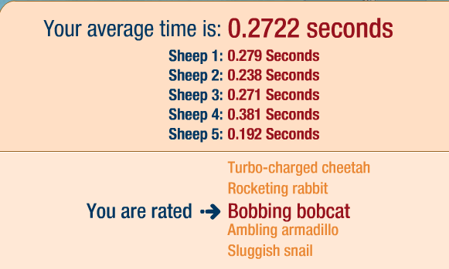
 | 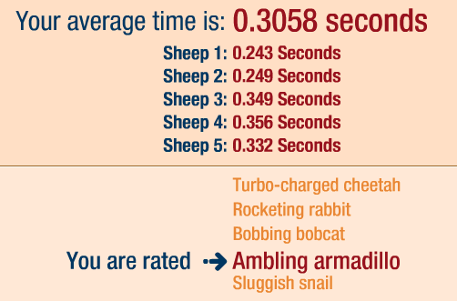 | 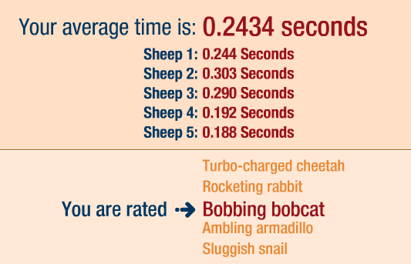
 | 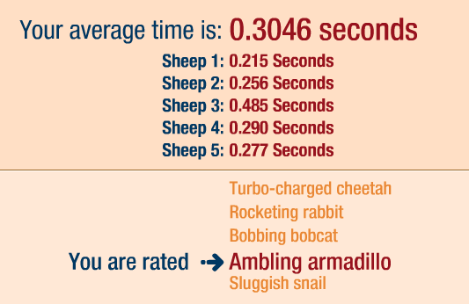 | 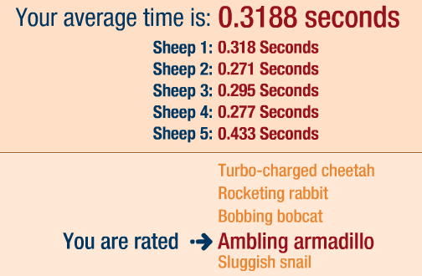

Sleeping Sheep – Example used with class
Problem:
Are Miss Gilmore’s reaction times faster than Miss Arnold’s reaction times?

Plan: Miss Gilmore and Miss Arnold did the “How fast is your reaction time?” activity 5 times each giving a total of 25 separate reaction times. Penalty reaction times will not be analysed.

Data: The reaction times for both were recorded.

Analysis:

Summary statistics | Miss Gilmore | Miss Arnold
Lowest value | 0.124 | 0.188
Lower Quartile | 0.246 | 0.225
Median | 0.251 | 0.271
Upper Quartile | 0.253 | 0.29
Highest value | 0.377 | 0.485

I notice…

Summary statistics

Shape of the data

Spread of the data

Middle 50% of the data

Conclusion:

Answer to the question

Supporting evidence

Generalisation (how might these sample findings relate to the population)

A good comparison question or problem should contain:

- Reference to the target population (scope of the investigation) e.g. year 10 students
- Reference to the variable being measured/investigated e.g. report marks
- Reference to the two groups being compared e.g. Maths, Science
- Some kind of comparison to be investigated (e.g. Maths higher than Science)

E.g. ‘I wonder if Year 10 science report marks are higher than Year 10 mathematics report marks?’

Statistics
In a range of meaningful contexts, students will be engaged in thinking mathematically and statistically. They will solve problems and model situations that require them to:

 | Statistical investigation | Statistical literacy | Probability
1 | S1-1 Conduct investigations using the statistical enquiry cycle:  A posing and answering questions  B gathering, sorting and counting, and displaying category data  C discussing the results. | S1-2 Interpret statements made by others from statistical investigations and probability activities. | S1-3 Investigate situations that involve elements of chance, acknowledging and anticipating possible outcomes.
2 | S2-1 Conduct investigations using the statistical enquiry cycle:  A posing and answering questions  B gathering, sorting, and displaying category and whole-number data  C communicating findings based on the data. | S2-2 Compare statements with the features of simple data displays from statistical investigations or probability activities undertaken by others. | S2-3 Investigate simple situations that involve elements of chance, recognising equal and different likelihoods and acknowledging uncertainty.
3 | S3-1 Conduct investigations using the statistical enquiry cycle:  A gathering, sorting, and displaying multivariate category and whole-number data and simple time-series data to answer questions  B identifying patterns and trends in context, within and between data sets  C communicating findings, using data displays. | S3-2 Evaluate the effectiveness of different displays in representing the findings of a statistical investigation or probability activity undertaken by others. | S3-3 Investigate simple situations that involve elements of chance by comparing experimental results with expectations from models of all the outcomes, acknowledging that samples vary.
4 | S4-1 Plan and conduct investigations using the statistical enquiry cycle:  A determining appropriate variables and data collection methods  B gathering, sorting, and displaying multivariate category, measurement, and time-series data to detect patterns, variations, relationships, and trends  C comparing distributions visually  D communicating findings, using appropriate displays. | S4-2 Evaluate statements made by others about the findings of statistical investigations and probability activities. | S4-3 Investigate situations that involve elements of chance by comparing experimental distributions with expectations from models of the possible outcomes, acknowledging variation and independence.  S4-4 Use simple fractions and percentages to describe probabilities.
5 | S5-1 Plan and conduct surveys and experiments using the statistical enquiry cycle:  A determining appropriate variables and measures  B considering sources of variation  C gathering and cleaning data  D using multiple displays, and re-categorising data to find patterns, variations, relationships, and trends in multivariate data sets  E comparing sample distributions visually, using measures of centre, spread, and proportion  F presenting a report of findings. | S5-2 Evaluate statistical investigations or probability activities undertaken by others, including data collection methods, choice of measures, and validity of findings. | S5-3 Compare and describe the variation between theoretical and experimental distributions in situations that involve elements of chance.  S5-4 Calculate probabilities, using fractions, percentages, and ratios.
6 | S6-1 Plan and conduct investigations using the statistical enquiry cycle:  A justifying the variables and measures used  B managing sources of variation, including through the use of random sampling  C identifying and communicating features in context (trends, relationships between variables, and differences within and between distributions), using multiple displays  D making informal inferences about populations from sample data  E justifying findings, using displays and measures. | S6-2 Evaluate statistical reports in the media by relating the displays, statistics, processes, and probabilities used to the claims made. | S6-3 Investigate situations that involve elements of chance:  A comparing discrete theoretical distributions and experimental distributions, appreciating the role of sample size  B calculating probabilities in discrete situations.

Overview of Possible Unit Plan (Level 5)

1.  - Posing Questions (using ‘I wonder…’).  - Sorting questions into summary, comparison, relationship. | 2.  - Re-write questions  - Answer questions using ‘I notice…’  - Construct graphs using data cards.  - Find and use statistical values. | 3.  - Write a conclusion using ‘I notice…’  - Draw a dot plot  - Find statistical values such as: maximum, minimum, range, median.
4.  - Calculate the five summary statistics for box and whisker plots.  - Draw box and whisker plots. | 5.  - Write a comparison question  - Draw a dot plot  - Compare box and whisker plots  - Write a conclusion from a box and whisker plot*. | 6.  - Draw side-by-side dot plots (or on top of each other)  -Draw side-by-side box and whisker plots  - Write a conclusion in response to a comparison question*.
7.  - Write an analysis when given dot plots and box plots*.  - Write a conclusion from your analysis and graphs (*use 4 features of analysis) | 8.  - *Features to discuss for analysis: compare summary statistics; look at the shape of the data, spread of data, and middle 50% of the data.  - *Features needed for conclusion: Show support or otherwise for hypothesis, justify/explain this, explain how the sample findings relate to the target population.  - Calculate the mean for a data set | 9.  Use ‘Speedsters’ lesson plan  (Teachers notes available form census at school website, as well as student worksheet).
10.  Use ‘Speedsters’ lesson plan  (Teachers notes available from census at school website, as well as student worksheet). | If there is any more time, keep going through the PPDAC cycle. Emphasise what students should be talking about for their analysis and conclusion. Look at the website www.censusatschool.org.nz as there are many activities and lesson plans that can be used.

Overview of Possible Unit Plan (Level 6)

1.  - Discuss PPDAC cycle  - Use data cards to introduce scatterplots  - Discuss sample/population  - Review of posing questions (summary, relationship, comparison questions using the starter ‘I wonder…’) | 2.  - Explore scatterplots, ‘Growing Scatterplots lesson’  - Analysis of scatterplots (using starter ‘I notice…’)  - Re-write questions | 3.  - More analysis of scatterplots  - Using words such as trend, shape, middle, spread, unusual.  - Writing conclusions (*Show support or otherwise for question, justify/explain this, explain how the sample findings relate to the target population)
4.  - Describing scatterplots lesson  - Make an analysis and conclusion from a variety of different scatterplots | 5.  - Posing more questions  - Writing a good comparison question  - Draw and compare dot plots  - Draw and compare box and whisker plots  - Write a conclusion from a box and whisker plot*. | 6.  - ‘Sleeping Sheep’ lesson  - Carry out activity on computers to gather data  - Discussion about cleaning data  - Begin entire PPDAC cycle (2-3 lessons)
7.  - Continue with ‘Sleeping Sheep’ lesson  8.  - Finish off ‘Sleeping Sheep’ lesson  - Model a good analysis and conclusion for students. | 9.  - Continue through PPDAC cycle  - Evaluate the statistical process | Remainder of lessons continue to practice PPDAC cycle, make sure students conclusions are making an inference for the population and justifying their findings.

