Telepathic or just pathetic?

Key ideas

This activity covers achievement objectives from across the different threads of the statistical thinking strand. Students working at this level should be considering/generating a range of statistical evidence and be able to assess the strength of this evidence. Prior to this activity, students should have experience with experimental design, sampling variability, the binomial distribution, and confidence intervals. They should be able to approach situations by asking themselves “Based on this population, what would I expect to see in samples……..” and “Based on this sample, what could I say about the population……”.

Problem | Are you telepathic?
Problem | Start the activity by pretending to read one of your student’s minds and then linking this through to a discussion on telepathy.  To allow the students to develop an informed contextual knowledge of the investigation, ask students to use the internet to research information about telepathy and possible ways for testing for telepathy (or prepare this information in advance for students to read). If students find any articles or reports about tests that have been done for telepathy, ask them to try to summarise the investigation using the statistical enquiry cycle (PPDAC).  Students should then be encouraged to evaluate the investigation by identifying any flaws in or concerns about the design or statistical methods used and suggesting improvements (see “Links to other threads” at the end of this activity for an example). | Telepathy describes the purported transfer of information on thoughts or feelings between individuals by means other than the five classical senses.  Various experiments have been used to test for telepathic abilities. Among the most well known are the use of Zener cards and the Ganzfeld experiment.  Zener cards are cards marked with five distinctive symbols. When using them, one individual is designated the "sender" and another the "receiver". The sender must select a random card and visualize the symbol on it, while the receiver must attempt to determine that symbol using Psi.  To show telepathy, the “receiver” must obtain statistically significant score higher than 20%.  (Source for information – Wikipedia).
Plan  Data | Prepare 30 large cards, made up of six of each the each five symbols. Don’t tell students that there are six of each symbol at this stage, but it is no big deal if they ask (except they may try to count cards). Shuffle the cards so that they are in random order. Ask the students to attempt to “receive” each of the “telepathic transmissions” and record which of the five symbols they think was transmitted. You might want to draw each of the five symbols on the white board so they can remember what the five options are. Move quickly through each card (students find it fun at first and then get a little bored around the half way mark). After all 30 transmissions are completed, go back through each card and call out/show the correct image. Finally, ask students to count up how many they got correct out of the 30 transmissions.
Analysis – seeking explanations | Go around the class and ask each person how many they got correct, collating the results straight onto a dot plot on the whiteboard/computer.  What do you notice about the results?  Do you think you are telepathic looking at these results?  Do you think anyone in the class is telepathic?  Why do you think they are telepathic?  Why did we get different results?  Did you just guess the images? Did anyone just put the same image down for all 30 transmissions?  What do we need to show to conclude whether someone is telepathic or not? |  | Example of results:  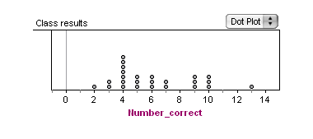  Selection of responses:  “I suck. I only got 2 correct, which is the lowest for the class”  “Getting six right is just guessing”  “Student A is pretty good, they got 13, it would be hard to guess that many right”  “People have different levels of telepathy?” “Nah, it’s because people were just guessing!”  That they weren’t just guessing.
Analysis using sampling distributions | Note: It is easier for students to deal with whole numbers than proportions in this approach. The focus of this approach is to look at what results you would get for an individual person who just guesses for each of the 30 transmissions. Students will compare individual results to a sampling distribution of guesses and see if they “fit”.
Analysis using sampling distributions | What is the probability of correctly guessing the image? If you just guessed for each of the 30 transmissions, how many would you expect to get correct?  If you did this experiment many times, what kind of results would you expect? Would you always get 6 and out 30 correct if you were just guessing?  Using appropriate technology, generate 1000 samples of 30 from a binomially distributed random variable/population with p = 0.2, with the measured variable being the number of correct transmissions out of 30, and display the results on a histogram. Ask the students what the graph represents.  Ask a student in the class how many they got correct e.g. 8.  Compare this result to the histogram which shows the variability you would expect each time you did the experiment if you were just guessing.  Why is it 8 or higher and not just counting how many times 8 comes up?  One possible explanation: you trying to work out if 8 far enough away from 6 to be considered different or not likely to have been obtained just by guessing. If it is special, you would expect many results to be equal to or higher than it. |  | The probability of correctly guessing the image is 0.2. So you would expect to get six right just from guessing because 20% of 30 is six.  You wouldn’t always get six correct – you might have a good luck and guess more than 20% right for some and get less for others.  1000 randomly generated samples of 30:  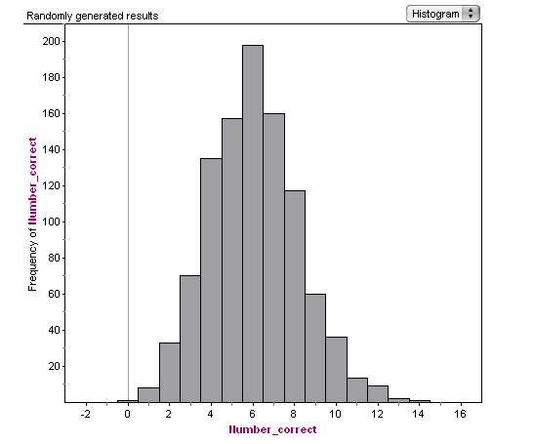  My result of 8 or higher comes up 238 times out of 1000.  8 seems to fit with what I would expect from just guessing the transmissions and not being telepathic.  How many correct do you think might be considered telepathic?  There are only 3 results out of 1000 for getting 13 or more correct, so maybe getting 13 correct because it would be very unlikely to guess that many correct.
Analysis using informal inferential techniques | In the previous approach, we generated evidence to help decide if your result was possible from guessing e.g. in the long run, you will get 20% correct for the transmissions or 6 correct. We established that even if you were guessing, you might not get exactly 6 correct transmissions out of 30 every time you do the experiment.  So what if actually you get 30% correct in the long run? Would you always expect to get 9 correct out of 30 every time you do the experiment? The approach for this analysis is to investigate the possibilities for the percentage of transmissions you can get correct in the long run (the population proportion).  Note: Potentially, a confidence interval could be constructed to estimate the population proportion. However, 30 might not be a large enough sample size for the sample proportion found for a student in the class and this approach avoids this issue.
Analysis using informal inferential techniques | Ask students to take the number the got correct out of 30 and turn it into a proportion. Is this higher than 20%? Are you telepathic?  What if you were just having a bad day? If you actually get 30% correct in the long run, could you get 8 out of 30 or 27% correct? |  | 8 out of 30 is 27%. It’s higher than 20%  I’m not telepathic because you can get 27% just by guessing, it’s not high enough.  Yep, I reckon, because it’s not that far below 30% and I wouldn’t always get 9 correct.
Analysis using informal inferential techniques | Using appropriate technology, generate 1000 samples of 30 from a binomially distributed random variable/population, changing the population proportions e.g. p = 0.1, p = 0.15, p = 0.2, p = 0.25, p = 0.3, with the measured variable being the number of correct transmissions out of 30. Display the results on histograms.  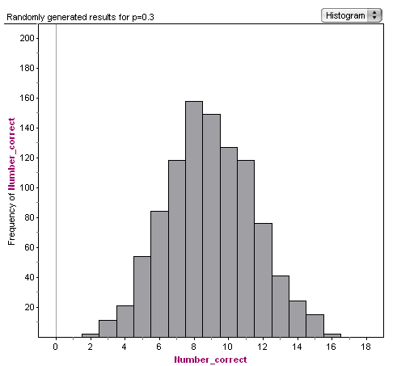  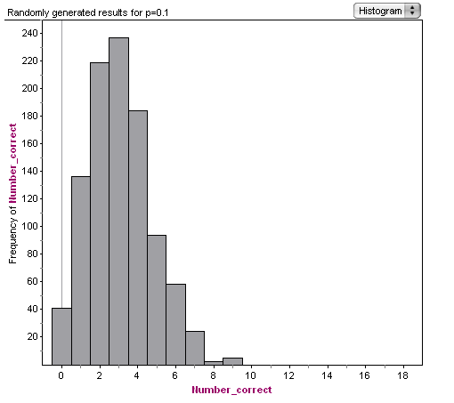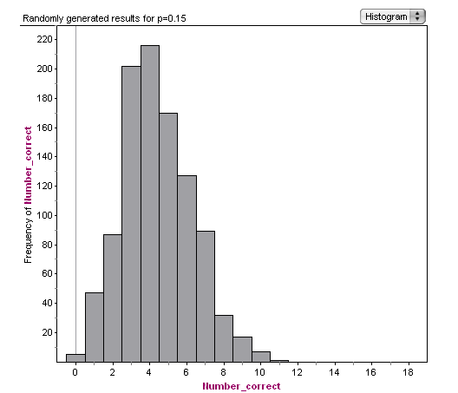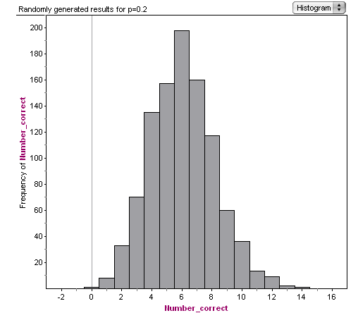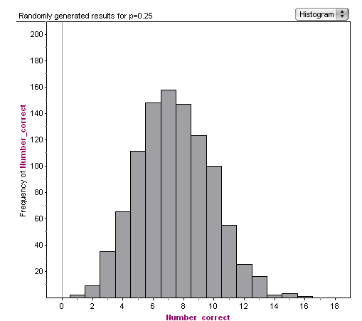  What do you notice about the shape of the graphs for the different proportions?  I notice that most of them are skewed, the p = 0.3 looks the most normally distributed.  Does this surprise you?  I thought that sample proportions were normally distributed……the sample is 30 (this needs addressing!)  How many did you get correct? What “long run” percentages could have produced this result in an experiment?  Getting 8 correct is likely for percentages of 15% (maybe 10%) up to 30% (and probably higher). Note: Be careful not to allow incorrect conclusions that they are more likely to be one percentage in the long run e.g. 8 is at the centre of the 25% graph, so I’m most likely to get 25% correct in the long run. Assuming telepathy will make you better than 20%, and there is some sort of scale to how telepathic you are, you’re telepathic “hit rate” is fixed and has no probability attached to it.  Instead, students should focus on the possibilities. They can conclude that, based on their result for this experiment, they could correctly receive in the long run anything from ____% to ___% of the transmissions. If 20% is one of the possible values, than there is not enough evidence to claim that you weren’t guessing the images.
Links to other threads | In this approach, the situation is modelled using the binomial distribution, and the probabilities are calculated based on the assumption of guessing the images.
Links to other threads | Could the results for this experiment be modelled by a binomial distribution? What are the features of this distribution and what assumptions do you need to make?  Calculate the probability of getting your result (i.e. the number you got correct) or higher if you guessed every image.  What is the number of images that the probability of guessing is at most 5%?  How many transmissions would you have to correctly receive to show that your result is significantly different from 20%? |  | The binomial distribution needs a fixed number of trials, the probability of success to be constant for each trial, that there are only two outcomes and that each trial is independent.  The probability of guessing each image is 0.2 and this is the same for each transmission. I assume that each transmission is independent? Teacher: I randomly shuffled the order of the cards.  Using the binomial distribution with n = 30 and p = 0.2, P(X ≥ 8) = 0.2393  Using graphics calculator, P(X ≥ 11) = 0.0257.  You would need to get 11 or more correct transmissions to show telepathy.
Conclusion | Ask students to use all of the statistical evidence available to answer the following questions:  Is there statistical evidence to support that you are telepathic?  What statistical evidence would be needed to show that someone is telepathic?  This should just be bringing together the conclusions they made for each approach to the analysis.
Reflection | Are there any flaws in the experiment?  Does the experiment need to be with five cards? Does the experiment need to be over 30 cards?  Why was there six of each card in the experiment? Why can’t you necessarily use confidence intervals for your sample?  How could you improve the experiment? Is it enough to show telepathy in one experiment? |  | Some student reflections:  There was only one “sender” and heaps of “receivers” - what if your signal was weakened?  Maybe you shouldn’t be able to see your previous answers because you might sub-consciously start choosing stars because you haven’t put many down…..
Links to other threads | Example of telepathic experiment:  Title: Testing for telepathy in connection with e-mails  Authors: SHELDRAKE Rupert; SMART Pamela  Source: Perceptual and motor skills (2005, vol. 101, no. 3, pp. 771 – 786)  Abstract: This study investigated possible telepathic communication in connection with e-mails. On each trial, there were four potential e-mailers, one of whom was selected at random by the experimenter. One minute before a prearranged time at which the e-mail was to be sent, the participant guessed who would send it. 50 participants (29 women and 21 men) were recruited through an employment web site. Of 552 trials, 235 (43%) guesses were hits, significantly above the chance expectation of 25%. Further tests with 5 participants (4 women, 1 man, ages 16 to 29) were video-taped continuously. On the filmed trials, the 64 hits of 137 (47%) were significantly above chance.

Zener cards:



